**IT equipment management system of**

**College of Arts, Media and Technology**

Software Design Document

By

**Mr. Nathawut Supavananusorn 542115020**

**Mr. Tanadol Parn-ong 542115021**

Department of Software Engineering

College of Arts, Media and Technology

Chiang Mai University

Project Advisor

________________________

**Dr. Prompong Sugunnasil**

**Document History**

|  |  |  |  |  |  |  |
| --- | --- | --- | --- | --- | --- | --- |
| **Document Name** | **Version** | **Status** | **Date** | **Viewable** | **Reviewer** | **Responsible** |
| **Documents** | | | | | | |
| IT equipment management system of College of Arts, Media and Technology - Software design_v0.1.docx | Add  Chapter One  - Purpose  - Software Scope  - Technology review  Chapter Two  Chapter Three  - Class Diagram  - Sequence Diagram  - Database Design | Draft | 22 June 2015 | NS, TP, PS | NS,TP | NS |
| IT equipment management system of College of Arts, Media and Technology - Software design_v1.0.docx | Fix  Chapter Three  - Class Diagram  - Sequence Diagram  - Database Design | Released | 9 July 2015 | NS, TP, PS | NS,TP | TP |

**\*NS = Nathawut Supavananusorn**

**\*TP = Tanadol Parn-ong**

**\*PS = Dr. Prompong Sugunnasin**

Contents

**Chapter One | Introduction** 4

**1.1** **Purpose** 4

**1.2 Software Scope** 4

**1.3 Technology Review** 5

**Chapter Two | System Architecture** 7

**Chapter Three | Detail Design** 8

**3.1 Class Diagram** 8

**3.2 Sequence Diagram** 40

**3.3 Database design** 120

# **Chapter One | Introduction**

## **Purpose**

The software design document (SDD) is written for describing the high level of software design, system architecture, database system and graphic user interfaces. It also consists of the users’ requirements. This document is an important thing for facilitating the developer team members to understand the direction for developing IT equipment management system of College of Arts, Media and Technology.

## **1.2 Software Scope**

This document describes the implementation details of IT equipment management system of College of Arts, Media and Technology. The system consists of seven features. The first feature is ‘Account Management’ which covers the management of the Technician and the Reporter by the Administrator (create an account and define active status). The second feature is ‘Login/Log out System’ which covers the log in/log out of the Administrator account, the Technician account, and the Reporter account. The third feature is ‘IT Equipment Management’. It covers management of IT equipment information by the Administrator consist of adding IT equipment, updating IT equipment and IT equipment deletion. The fourth feature is ‘Management Information System’ that covers viewing the summary report of IT equipment expiration and IT equipment that are often broken. The fifth feature is ‘Repair Informing system’ which includes repair informing by the Reporter and viewing the history of his repair information by himself. The sixth feature is ‘Repair Management System’ which includes viewing the repair job detail, updating the repair job, viewing the history of repair jobs and getting the tasks automatically by the Technician. Moreover, this feature also covers defining the repair's type and requesting to distribute repair tasks again to the system by the Administrator. And the last feature is ‘Tracking System’ which includes receiving the repair informing by the Technician and receiving the updating of repair status by the Reporter via email. This document explains how all features in the application are implemented using class diagrams and sequence diagrams for clarifying and providing the overall picture of the system.

## **1.3 Technology Review**

1.3.1 ASP.Net MV

Technology description

MVC is a framework for building web application using MVC design pattern. The concept of MVC design pattern will manage (separate) task and element in application to easy for building and development.

Alternative technology

- PHP

The selection of this technology

* ASP.NET MVC can build dynamic web application.
* ASP.NET MVC is easy to adapt object oriented programming concept.

Cascading Style Sheets 3 (CSS3)

1.3.2 Cascading Style Sheets 3 (CSS3)

Technology description

CSS3 is a Style Sheets language to help to define the look and formatting of a document written in a markup language. It is commonly used to create interfaces written in HTML and XHML

Alternative technology

- CSS2

The selection of this technology

* CSS3 is easier to implement page layout.
* CSS3 is considered a clean coding technique.
* CSS3 can work with HTML5 and provide a richer set of features (e.g. text effects, 2D/3D transformations, animations).

1.3.3 HTML5

Technology description

Hypertext Markup Language (HTML) is a standard language for using design web pages. HTML use Tag for define HTML displaying. HTML language is a Markup language that use for building web pages. HTML has a template from SGML (Standard Generalized Markup Language) to understand and easy to learn. Currently being developed and standardized by the World Wide Web Consortium (W3C).

Alternative technology

- HTML4

The selection of this technology

* HTML5 can access sites easier than older version.
* HTML5 is support multimedia content.
* HTML5 is standardized for creating the user interface of website.

1.3.4 JavaScript

Technology description

JavaScript is a programming language known as the “script”. Translation operates on each command. It is commonly used as part of web browsers, which allow client-side scripts to interact with the user, control the browser, and change the content displayed on the We can add the JavaScript programming web pages to process data of both the display and receiving - transmitting. And that can interact with users immediately. JavaScript is also used in server-side programming and building games as well as desktop and mobile applications.

Alternative technology

- None

The selection of this technology

* We use JavaScript for calculating data, displaying, sending – receiving data for interacting with the user.
* JavaScript is easy to learn.

# **Chapter Two | System Architecture**

**(Microsoft SQL server)**

DB

**(ASP.NET MVC) M**

Web application

**(IIS)**



**(Google Chrome)**

Web browser

*Figure 8 the architecture of IT equipment management system of College of Arts, Media and Technology*

The architecture of IT equipment management system of College of Arts, Media and Technology is shown in Figure 15. This system consists web application which is created by ASP.NET MVC and database which is Microsoft SQL server. The user can access by using a web browser. In this progress, we test on Google Chrome only.

# **Chapter Three | Detail Design**

## **3.1 Class Diagram**

**Class Description**

**3.1.1 Class-01. HomeController**

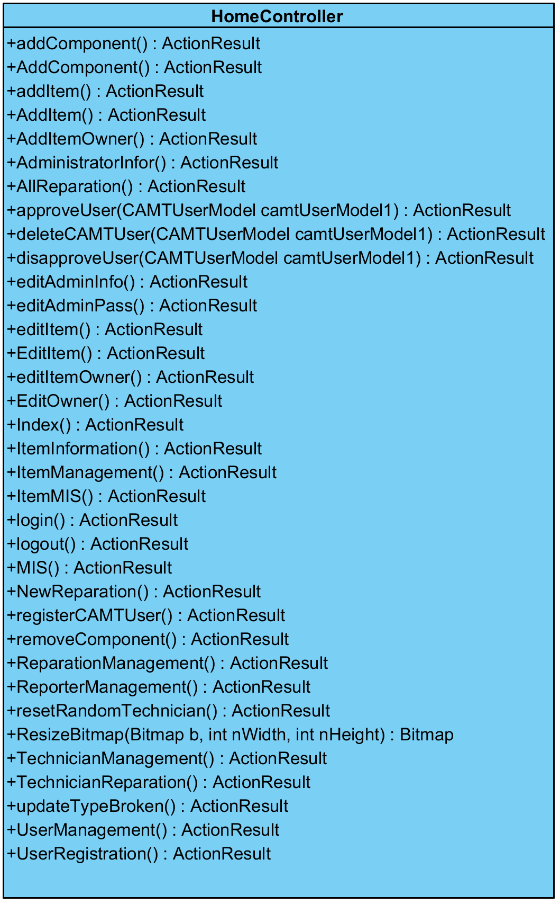

**Description**

This class is Controller class that handles interact between Home View package and Model package.

**Method**

|  |  |  |  |  |
| --- | --- | --- | --- | --- |
| No. | Name | Description | Parameters | Return |
|  | addComponent() | This method is used for sending data to add new component. | None | ActionResult |
|  | AddComponent() | This method is used for returning AddComponent page to User | None | ActionResult |
|  | addItem() | This method is used for sending data to add new item. | None | ActionResult |
|  | AddItem() | This method is used for returning AddItem page to User | None | ActionResult |
|  | AddItemOwner() | This method is used for returning AddItemOwner page to User | None | ActionResult |
|  | AdministratorInfor() | This method is used for returning Administrator information page to User | None | ActionResult |
|  | AllReparation() | This method is used for returning All Reparation page to User | None | ActionResult |
|  | approveUser() | This method is used for sending data to change user active. | camtUserModel1: CAMTUserModel | ActionResult |
|  | deleteCAMTUser() | This method is used for sending data to delete user account. | camtUserModel1: CAMTUserModel | ActionResult |
|  | disapproveUser() | This method is used for sending data to change user active. | camtUserModel1: CAMTUserModel | ActionResult |
|  | editAdminInfo() | This method is used for sending data to edit Administrator information. | None | ActionResult |
|  | editAdminPass() | This method is used for sending data to edit Administrator password. | None | ActionResult |
|  | editItem() | This method is used for sending data to edit the item information. | None | ActionResult |
|  | EditItem() | This method is used for returning All Edit item page to User | None | ActionResult |
|  | editItemOwner() | This method is used for sending data to update owner item. | None | ActionResult |
|  | EditOwner() | This method is used for returning Edit Owner item page to User | None | ActionResult |
|  | Index() | This method is used for returning Index page to User | None | ActionResult |
|  | ItemInformation() | This method is used for returning Item Information page to User | None | ActionResult |
|  | ItemManagement() | This method is used for returning Item Management page to User | None | ActionResult |
|  | ItemMIS | This method is used for returning Item MIS page to User | None | ActionResult |
|  | login() | This method is used for sending data to authorize for using system. | None | ActionResult |
|  | logout() | This method is used for requesting to logout. | None | ActionResult |
|  | MIS() | This method is used for returning Item Management information page to User | None | ActionResult |
|  | NewReparation() | This method is used for returning New Reparation page to User | None | ActionResult |
|  | registerCAMTUser() | This method is used for sending data to insert a user account to the system. | None | ActionResult |
|  | removeComponent() | This method is used for sending data to removing a user account. | None | ActionResult |
|  | ReparationManagement() | This method is used for returning Reparation Management page to User | None | ActionResult |
|  | ReporterManagement() | This method is used for returning Reporter Management page to User | None | ActionResult |
|  | resetRandomTechnician() | This method is used for sending data to random distribute work again. | None | ActionResult |
|  | ResizeBitmap() | This method is used for changing size of image. | B:Bitmap, nWidth:int, nHeight:int | ActionResult |
|  | TechnicianManagement() | This method is used for returning Technician Management page to User | None | ActionResult |
|  | TechnicianReparation() | This method is used for returning Technician Reparation page to User | None | ActionResult |
|  | updateTypeBroken() | This method is used for sending data to update type of broken IT equipment. | None | ActionResult |
|  | UserManagement() | This method is used for returning User management page to User | None | ActionResult |
|  | UserRegistration() | This method is used for returning User Registratrion page to User | None | ActionResult |

**3.1.2 Class-02. TechnicianController**

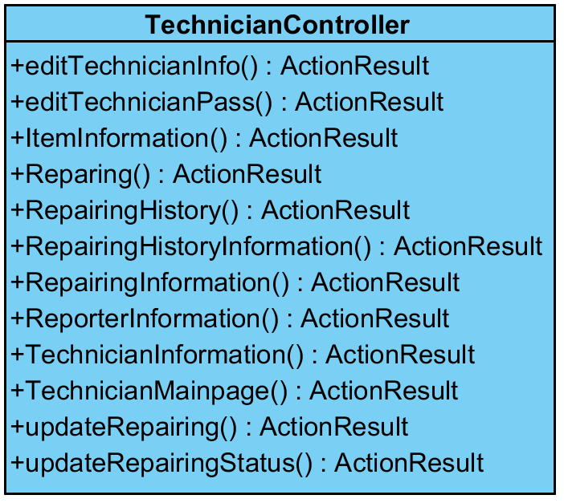

**Description**

This class is Controller class that handles interact between Technician View package and Model package.

**Method**

|  |  |  |  |  |
| --- | --- | --- | --- | --- |
| No. | Name | Description | Parameters | Return |
|  | editTechnicianInfo() | This method is used for sending data to edit technician information. | None | ActionResult |
|  | editTechnicianPass() | This method is used for sending data to edit technician password. | None | ActionResult |
|  | ItemInformation() | This method is used for returning Item Information page to User | None | ActionResult |
|  | Reparing() | This method is used for returning Repairing page to User | None | ActionResult |
|  | RepairingHistory() | This method is used for returning History of Repairing page to User | None | ActionResult |
|  | RepairingHistoryInformation() | This method is used for returning History of Repairing information page to User | None | ActionResult |
|  | RepairingInformation() | This method is used for returning Repairing Information page to User | None | ActionResult |
|  | ReporterInformation() | This method is used for returning Reporter Information page to User | None | ActionResult |
|  | TechnicianInformation() | This method is used for returning Technician Information page to User | None | ActionResult |
|  | TechnicianMainpage() | This method is used for returning Technician Main page to User | None | ActionResult |
|  | updateRepairing() | This method is used for sending data to update repairing information. | None | ActionResult |
|  | updateRepairingStatus() | This method is used for sending data to update repairing description. | None | ActionResult |

**3.1.3 Class-03. ReporterController**

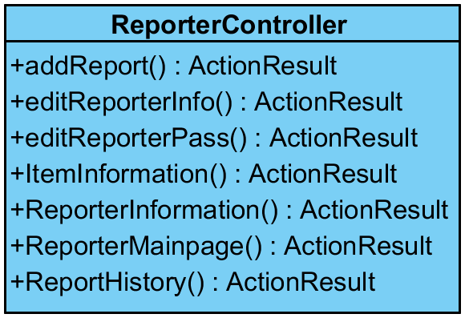

**Description**

This class is Controller class that handles interact between Reporter View package and Model package.

**Method**

|  |  |  |  |  |
| --- | --- | --- | --- | --- |
| No. | Name | Description | Parameters | Return |
|  | addReport() | This method is used for sending data to add a report to the system. | None | ActionResult |
|  | editReporterInfo() | This method is used for sending data to edit Reporter information. | None | ActionResult |
|  | editReporterPass() | This method is used for sending data to edit Reporter password. | None | ActionResult |
|  | ItemInformation() | This method is used for returning Item Information page to User | None | ActionResult |
|  | ReporterInformation() | This method is used for returning Reporter Information page to User | None | ActionResult |
|  | ReporterMainpage() | This method is used for returning Reporter Main page to User | None | ActionResult |
|  | ReporterHistory() | This method is used for returning History of report page to User | None | ActionResult |

**3.1.4 Class-04. CAMTUserModel**

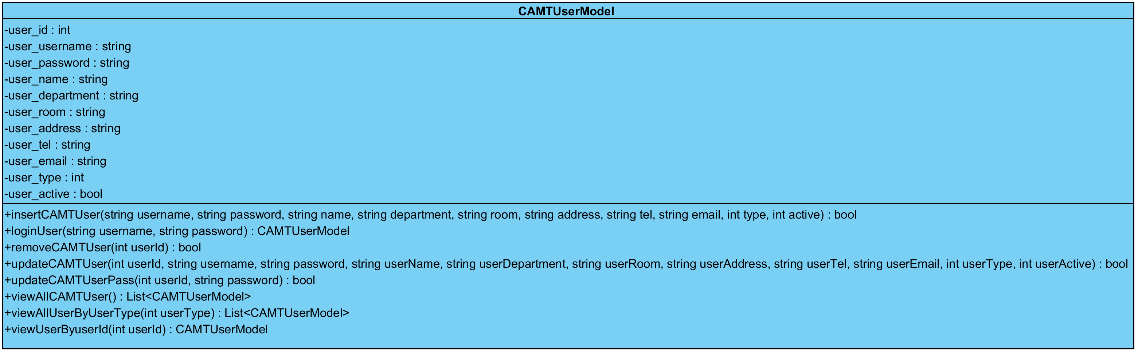

**Description**

This class is Model class of the CAMT user.

**Attribute**

|  |  |  |  |
| --- | --- | --- | --- |
| No. | Name | Description | Type |
|  | user_id | The user’s identifier | int |
|  | user_username | The user’s username | string |
|  | user_password | The user’s password | string |
|  | user_name | The user’s name | string |
|  | user_department | The user’s department | string |
|  | user_room | The user’s room | string |
|  | user_address | The user’s address | string |
|  | user_tel | The user’s telephone number | string |
|  | user_email | The user’s email | string |
|  | user_type | The type of user which consist Administrator, Technician, and Reporter. | int |
|  | user_active | The active status of user | bool |

**Method**

|  |  |  |  |  |
| --- | --- | --- | --- | --- |
| No. | Name | Description | Parameters | Return |
|  | insertCAMTUser() | This method is used for adding user account to the system. | username:string, password:string, name:string, department:string, room:string, address:string, tel:string, email:string, type:int, active:bool | bool |
|  | loginUser() | This method is used for authorizing the user to use the system. | username:string, password:string | CAMTUserModel |
|  | removeCAMTUser | This method is used for removing the user account in the system. | userId:int | bool |
|  | updateCAMTUser | This method is used for updating the user information in the system. | userId:int, usename:string, password:string, name:string, department:string, room:string, address:string, tel:string, email:string, type:int, active:bool | bool |
|  | updateCAMTUserPass | This method is used for updating the user password in the system. | userId:int, password:string | bool |
|  | viewAllCAMTUser() | This method is used for getting all user account from the system. | None | List<CAMTUserModel> |
|  | viewAllUserByUserType() | This method is used for getting all user account by identifying from user type. | userType:int | List<CAMTUserModel> |
|  | viewUserByuserId() | This method is used for getting user account information by identifying from user id. | userId:int | List<CAMTUserModel> |

**3.1.5 Class-05. ItemModel**

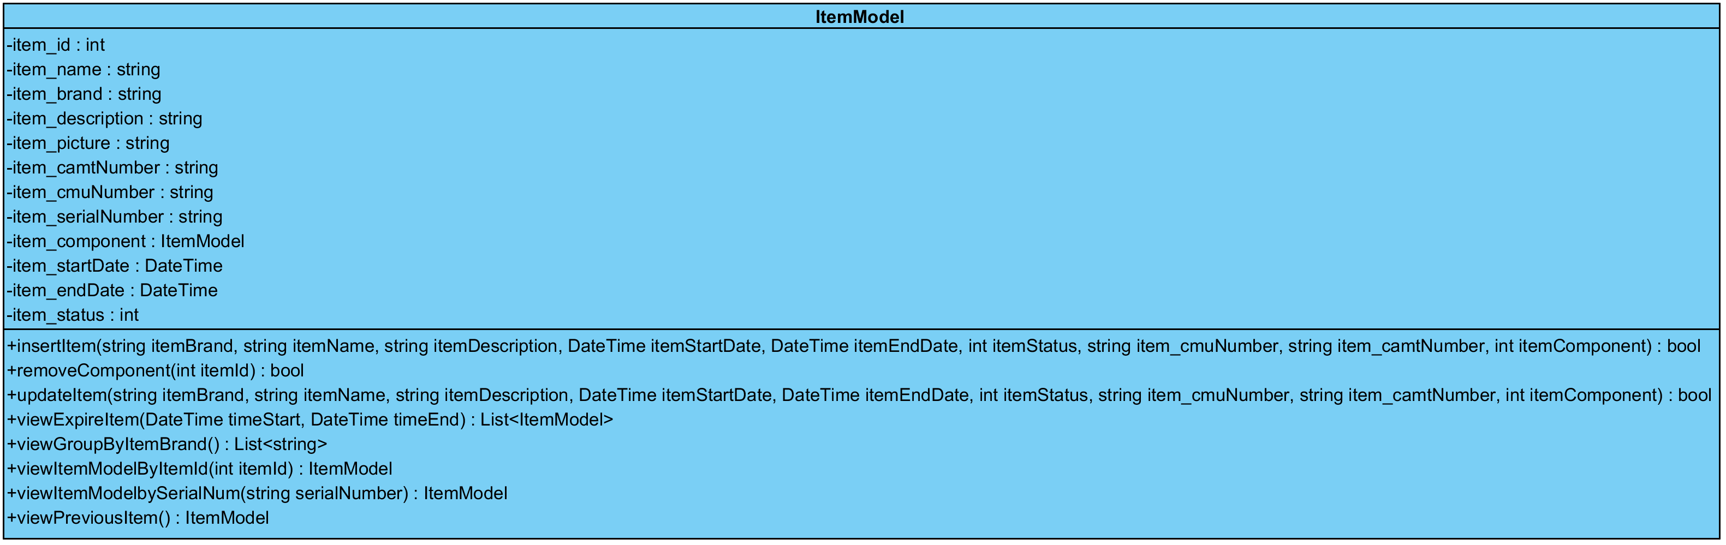

**Description**

This class is Model class of Item (IT equipment).

**Attribute**

|  |  |  |  |
| --- | --- | --- | --- |
| No. | Name | Description | Type |
|  | item_id | The IT equipment identifier | int |
|  | item_name | The IT equipment name | string |
|  | item_brand | The IT equipment brand | string |
|  | item_description | The IT equipment description | string |
|  | item_picture | The IT equipment picture | string |
|  | item_camtNumber | The CAMT number of IT equipment | string |
|  | item_cmuNumber | The CMU number of IT equipment | string |
|  | item_serialNumber | The serial number of IT equipment | string |
|  | item_component | The Component of IT Equipment | int |
|  | item_startDate | The registration date when IT Equipment is recorded in the system | DateTime |
|  | item_endDate | The expire date of IT Equipment | DateTime |
|  | item_status | The status of IT equipment Which consist normal, broken, expire. | int |

**Method**

|  |  |  |  |  |
| --- | --- | --- | --- | --- |
| No. | Name | Description | Parameters | Return |
|  | insertItem() | This method is used for adding IT equipment information to the system. | itemName:string, itemBrand:string, itemDescription:string, itemPicture:string, item_camtNumber:string, item_cmuNumber:string, itemComponent:ItemModel, itemStartDate:DateTime, itemEndDate:DateTime, itemStatus:int | bool |
|  | removeComponent() | This method is used for removing IT equipment information in the system. | itemId:int | bool |
|  | updateItem() | This method is used for updating IT equipment information in the system. | itemName:string, itemBrand:string, itemDescription:string, itemPicture:string, item_camtNumber:string, item_cmuNumber:string, itemComponent:ItemModel, itemStartDate:DateTime, itemEndDate:DateTime, itemStatus:int | bool |
|  | viewExpireItem() | This method is used for getting expire IT equipment information. | timeStart:DateTime, tiemEnd:DateTime | List<ItemModel> |
|  | viewGroupByItemBrand() | This method is used for getting all IT equipment brand. | None | List<string> |
|  | viewItemModelByItemId() | This method is used for getting IT equipment information by identifying from item id. | itemId:int | ItemModel |
|  | viewItemModelBySerialNum() | This method is used for getting IT equipment information by identifying from serial number. | serialNumber:string | ItemModel |
|  | viewPreviousItem() | This method is used for getting last IT equipment information that is added to the system. | None | ItemModel |

**3.1.6 Class-6. ItemOwnerModel**

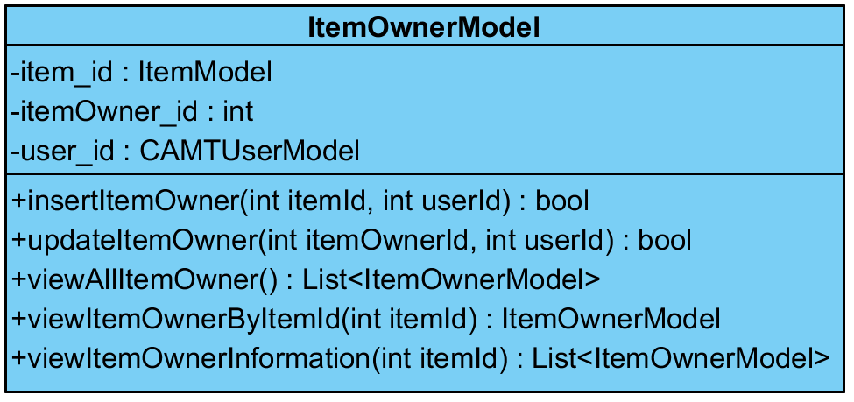

**Description**

This class is Model class of relation between item and user.

**Attribute**

|  |  |  |  |
| --- | --- | --- | --- |
| No. | Name | Description | Type |
|  | item_id | The IT equipment identifier | int |
|  | itemOwner_id | The IT equipment owner identifier | int |
|  | user_id | The user identifier | CAMTUserModel |

**Method**

|  |  |  |  |  |
| --- | --- | --- | --- | --- |
| No. | Name | Description | Parameters | Return |
|  | insertItemOwner() | This method is used for adding relation information between IT equipment and user | itemId:int, userId:int | bool |
|  | updateItemOwner() | This method is used for updating relation information between IT equipment and user | itemOwnerId:int, userId:int | bool |
|  | viewAllItemOwner() | This method is used for getting all IT equipment owner information from the system. | None | List<ItemOwnerModel> |
|  | viewItemOwnerByItemId() | This method is used for getting IT equipment owner information by identifying from item id. | itemId:int | ItemOwnerModel |
|  | viewItemOwnerInformation() | This method is used for getting IT equipment and component of IT equipment and by identifying from item id. | itemId:int | List<ItemOwnerModel> |

**3.1.7 Class-7. ReportModel**

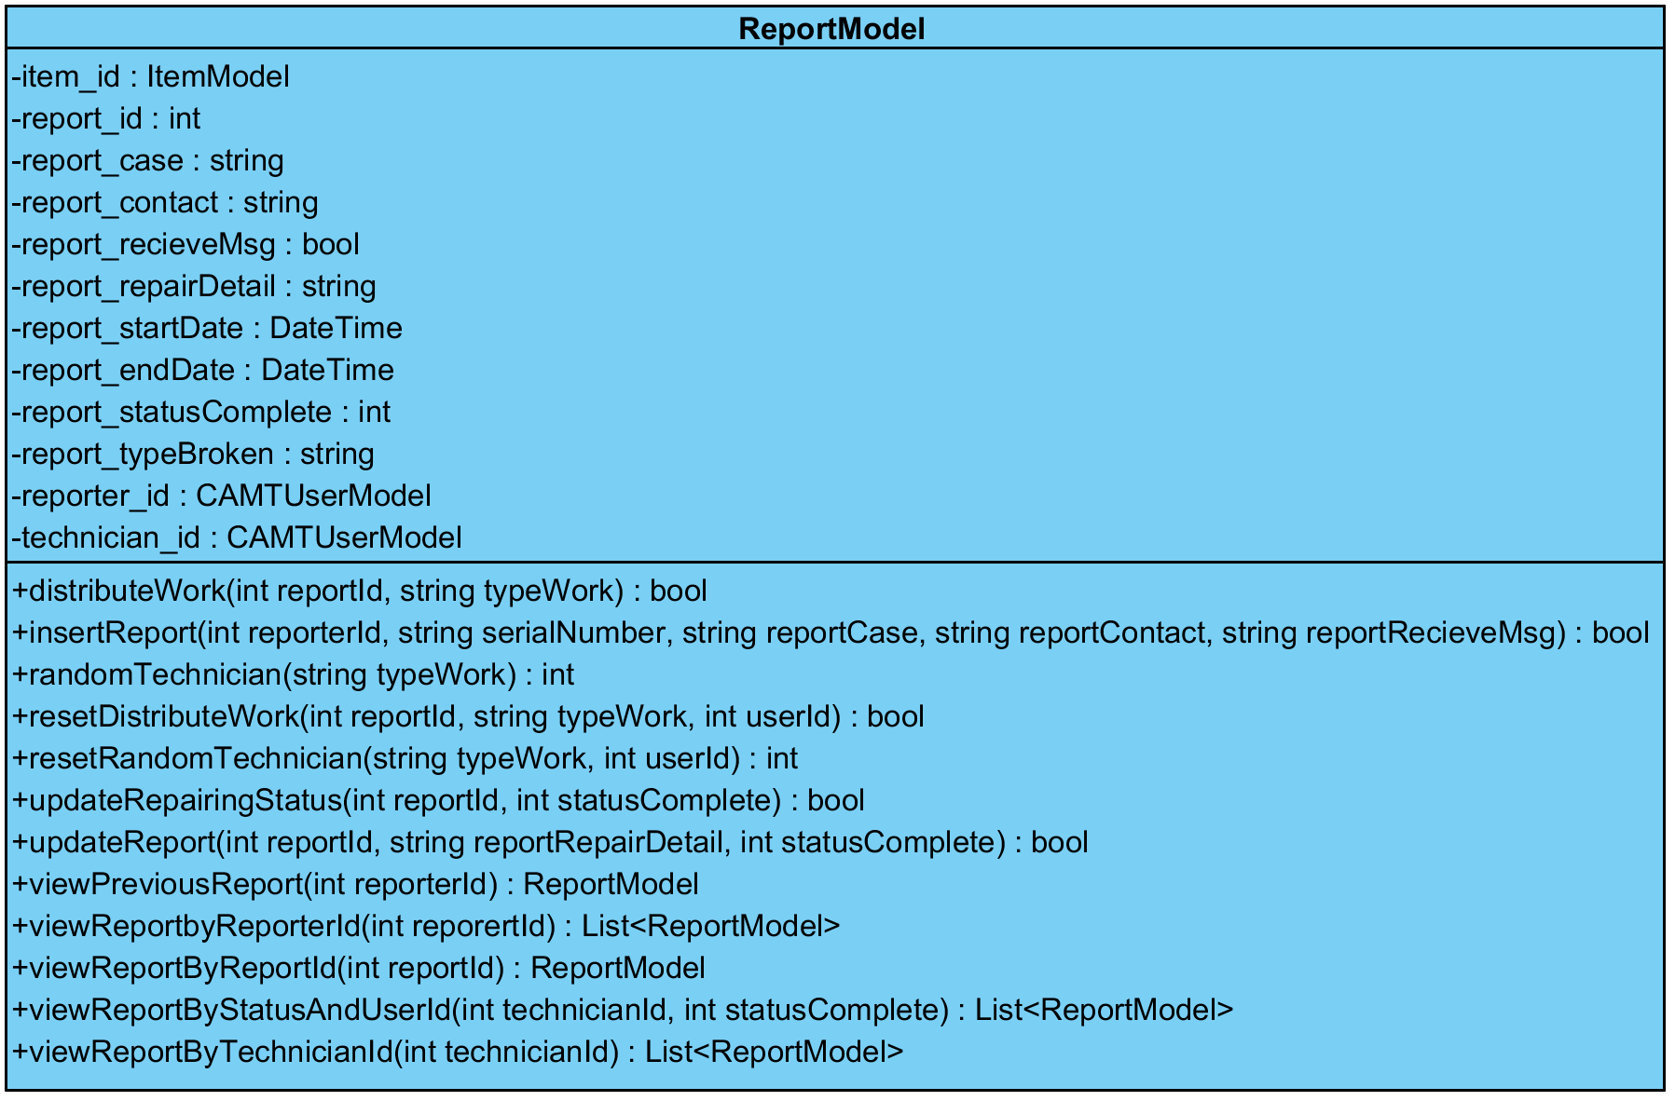

**Description**

This class is Model class of Report

**Attribute**

|  |  |  |  |
| --- | --- | --- | --- |
| No. | Name | Description | Type |
|  | item_id | The IT equipment identifier | int |
|  | report_id | The report idetifier | int |
|  | report_case | Broken IT equipment description that reporter send to the system. | string |
|  | report_contact | Contact detail that reporter send to the system. | string |
|  | report_recieveMsg | Notification status that reporter would like to get notification about new reparation progress description. | bool |
|  | report_repairDetail | Reparation detail that technician records to the system. | string |
|  | report_startDate | Start time that technician start to repair IT equipment. | DateTime |
|  | report_endDate | End time that technician repair IT equipment complete. | DateTime |
|  | report_statusComplete | Status of repair complete, which consist ( 0: wait to define type of broken, 1: wait to technician repair, 2: In repair process, 3: repair complete) | int |
|  | report_typeBroken | Type of broken IT equipment. | string |
|  | reporter_id | The reporter identifier | CAMTUserModel |
|  | technician_id | The technician identifier | CAMTUserModel |

**Method**

|  |  |  |  |  |
| --- | --- | --- | --- | --- |
| No. | Name | Description | Parameters | Return |
|  | distributeWork() | This method is used for distributing work to a technician. | reportId:int, typeWork:string | bool |
|  | insertReport() | This method is used for adding a report to the system. | reporterId:int, serialNumber:string, reportCase:string, reportContact:string, reportRecieveMsg:string | bool |
|  | randomTechnician() | This method is used for finding technician that can do a work. | typeWork:string | int |
|  | resetDistributeWork() | This method is used for distributing work to a technician again. | reportId:int, typeWork:string, userId:int | bool |
|  | resetRandomTechnician() | This method is used for finding technician that can do a work again. | typeWork:string, userId:int | int |
|  | updateRepairingStatus() | This method is used for updating a status complete in the system. | reportId:int, statusComplete:int | bool |
|  | updateReport() | This method is used for updating repair detail and status complete in the system. | reportId:int, reportRepairDetail:string, statusComplete:int | bool |
|  | viewPreviousReport() | This method is used for getting last report information that reporter inform to the system. | reporterId:int | ReportModel |
|  | viewReportbyReporterId() | This method is used for getting all report of reporter by identifying from reporter id. | reporterId:int | List< ReportModel > |
|  | viewReportByReportId() | This method is used for getting report information identifying from report id. | reportId:int | ReportModel |
|  | viewReportByStatusAndUserId() | This method is used for getting all report by identifying from technician id and status complete. | technicianId:int, statusComplete:int | List< ReportModel > |
|  | viewReportByTechnicianId() | This method is used for getting all report by identifying from technician id. | technicianId:int | List< ReportModel > |

**3.1.8 Class-8. MailAPI**

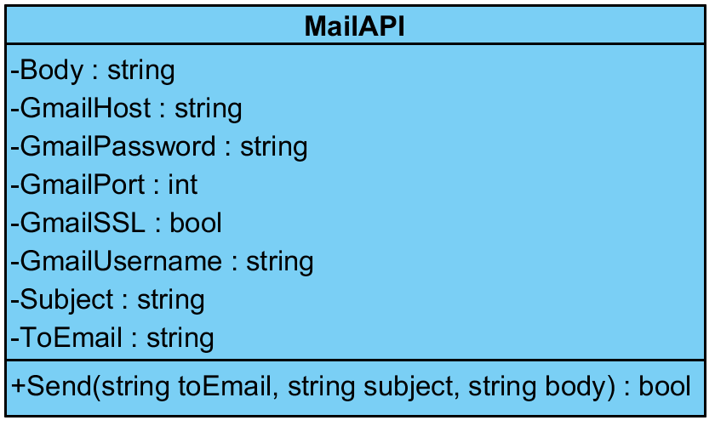

**Description**

This class is Mail class which handles to send mails to clients.

**Attribute**

|  |  |  |  |
| --- | --- | --- | --- |
| No. | Name | Description | Type |
|  | Body | Body content of email. | string |
|  | Host | Host name of email provider | string |
|  | Password | Password for authorizing to use mail API | string |
|  | Port | Port for using mail API | int |
|  | SSL | Secure Sockets Layer status of using email API | bool |
|  | Username | User for authorizing to use mail API | string |
|  | Subject | Subject of email that will send to clients. | string |
|  | ToEmail | Destination email that will send to clients. | string |

**Method**

|  |  |  |  |  |
| --- | --- | --- | --- | --- |
| No. | Name | Description | Parameters | Return |
|  | Send() | This method is used for sending email to clients. | toEmail:string, subject:string, body:string | bool |

**3.1.9 Class-9. ICAMTUserRepo**

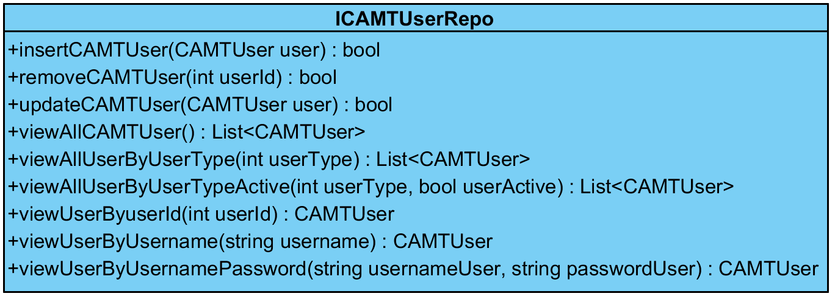

**Description**

This class is an interface class of CAMTUserRepo class.

**Method**

|  |  |  |  |  |
| --- | --- | --- | --- | --- |
| No. | Name | Description | Parameters | Return |
|  | insertCAMTUser() | This method is used for inserting a user account to the system. | user:CAMTUser | bool |
|  | removeCAMTUser() | This method is used for removing a user account in the system. | userId:int | bool |
|  | updateCAMTUser() | This method is used for updating a user account information in the system. | user:CAMTUser | bool |
|  | viewAllCAMTUser() | This method is used for viewing all user account information in the system. | None | List<CAMTUser> |
|  | viewAllUserByUserType() | This method is used for viewing a list of user account information by identifying from user type. | userType:int | List<CAMTUser> |
|  | viewAllUserByUserTypeActive() | This method is used for viewing all user account information by identifying from user type and user active. | userType:int, userActive:bool | List<CAMTUser> |
|  | viewUserByuserId() | This method is used for viewing a user account information by identifying from user id. | userId:int | CAMTUser |
|  | viewUserByUsername() | This method is used for viewing all user account information by identifying from username. | username:string | CAMTUser |
|  | viewUserByUsernamePassword() | This method is used for viewing a user account information by identifying from username and password. | usernameUser:string, passwordUser:string | CAMTUser |

**3.1.10 Class-10. IItemRepo**

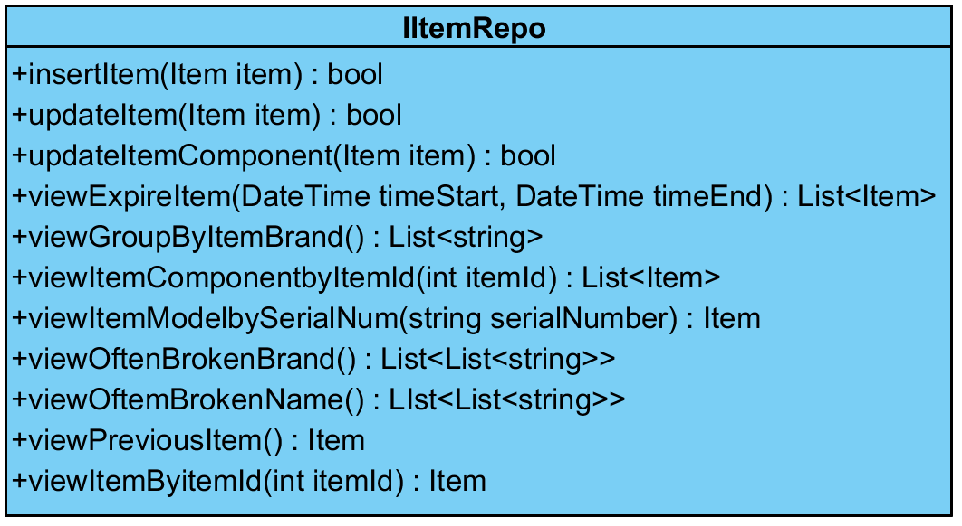

**Description**

This class is an interface class of ItemRepo class .

**Method**

|  |  |  |  |  |
| --- | --- | --- | --- | --- |
| No. | Name | Description | Parameters | Return |
|  | insertItem() | This method is used for inserting an IT equipment information to the system. | item:Item | bool |
|  | updateItem() | This method is used for updating an IT equipment information to the system. | item:Item | bool |
|  | updateItemComponent() | This method is used for updating an IT equipment component to the system. | item:Item | bool |
|  | viewExpireItem() | This method is used for getting expire IT equipment information. | timeStart:DateTime, timeEnd:DateTime | List<Item> |
|  | viewGroupByItemBrand() | This method is used for getting all IT equipment brand. |  | List<string> |
|  | viewItemComponentbyItemId() | This method is used for getting all components of IT equipment. | itemId:int | List<Item> |
|  | viewItemModelbySerialNum() | This method is used for getting IT equipment information by identifying from serial number. | serialNumber:string | Item |
|  | viewOftenBrokenBrand() | This method is used for getting IT equipment brand often are broken. | None | List<List<string>> |
|  | viewOftenBrokenName() | This method is used for getting IT equipment name often are broken. | None | List<List<string>> |
|  | viewPreviousItem() | This method is used for getting last IT equipment information that is added to the system. | None | Item |
|  | viewItemByitemId() | This method is used for viewing an IT equipment information by identifying from item id. | itemId:int | Item |

**3.1.11 Class-11. IItemOwnerRepo**

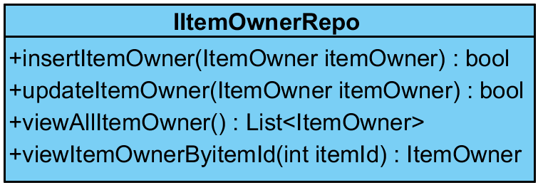

**Description**

This class is an interface class of ItemOwnerRepo.

**Method**

|  |  |  |  |  |
| --- | --- | --- | --- | --- |
| No. | Name | Description | Parameters | Return |
|  | insertItemOwner() | This method is used for inserting item owner information to the system. | itemOwner:ItemOwner | bool |
|  | updateItemOwner() | This method is used for updating item owner information in the system. | itemOwner:ItemOwner | bool |
|  | viewAllItemOwner() | This method is used for viewing all item owner information in the system. | None | List<ItemOwner> |
|  | viewItemOwnerByitemId() | This method is used for viewing item owner information by identifying from item id. | itemId:int | ItemOwner |

**3.1.12 Class-12. IReportRepo**

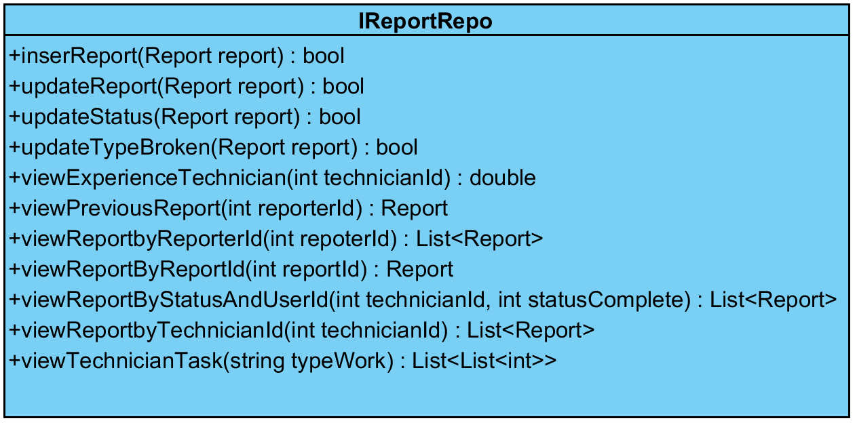

**Description**

This class is an interface class of ReportRepo class.

**Method**

|  |  |  |  |  |
| --- | --- | --- | --- | --- |
| No. | Name | Description | Parameters | Return |
|  | insertReport() | This method is used for inserting report information to the system. | report:Report | bool |
|  | updateReport() | This method is used for updating report information in the system. | report:Report | bool |
|  | updateStatus() | This method is used for updating report status in the system. | report:Report | bool |
|  | updateTypeBroken() | This method is used for updating report broken type of IT equipment in the system. | report:Report | bool |
|  | viewExperienceTechnician() | This method is used for viewing time that technician will complete all remaining work. | technicianId:int | double |
|  | viewPreviousReport | This method is used for viewing last report which is added by reporter. | reporterId:int | Report |
|  | viewReportbyReporterId() | This method is used for viewing all report information in the system by identifying from reporter id. | reporterId:int | List<Report> |
|  | viewReportByReportId() | This method is used for viewing report information in the system by identifying from report id. | reportId:int | Report |
|  | viewReportByStatusAndUserId() | This method is used for viewing all report information in the system by identifying from technician id and report status complete | technicianId:int, statusComplete | List<Report> |
|  | viewReportbyTechnicianId)_ | This method is used for viewing all report information in the system by identifying from technician id. | technicianId:int | List<Report> |
|  | viewTechnicianTask() | This method is used for viewing amount of technician and technician id that ever repair in that type work. | typeWork:string | List<List<int>> |

**3.1.13 Class-13. CAMTUserRepo**

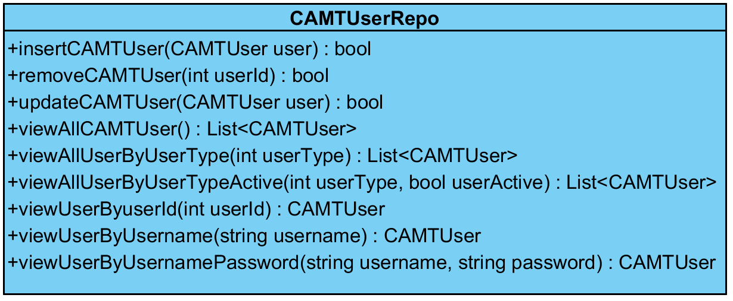

**Description**

This class is a repository class which handles about querying of the CAMTUser table in database.

**Method**

|  |  |  |  |  |
| --- | --- | --- | --- | --- |
| No. | Name | Description | Parameters | Return |
|  | insertCAMTUser() | This method is used for inserting a user account to the system. | user:CAMTUser | bool |
|  | removeCAMTUser() | This method is used for removing a user account in the system. | userId:int | bool |
|  | updateCAMTUser() | This method is used for updating a user account information in the system. | user:CAMTUser | bool |
|  | viewAllCAMTUser() | This method is used for viewing all user account information in the system. | None | List<CAMTUser> |
|  | viewAllUserByUserType | This method is used for viewing a list of user account information by identifying from user type. | userType:int | List<CAMTUser> |
|  | viewAllUserByUserTypeActive | This method is used for viewing all user account information by identifying from user type and user active. | userType:int, userActive:bool | List<CAMTUser> |
|  | viewUserByuserId | This method is used for viewing a user account information by identifying from user id. | userId:int | CAMTUser |
|  | viewUserByUsername | This method is used for viewing all user account information by identifying from username. | username:string | CAMTUser |
|  | viewUserByUsernamePassword | This method is used for viewing a user account information by identifying from username and password. | usernameUser:string, passwordUser:string | CAMTUser |

**3.1.14 Class-14. ItemRepo**

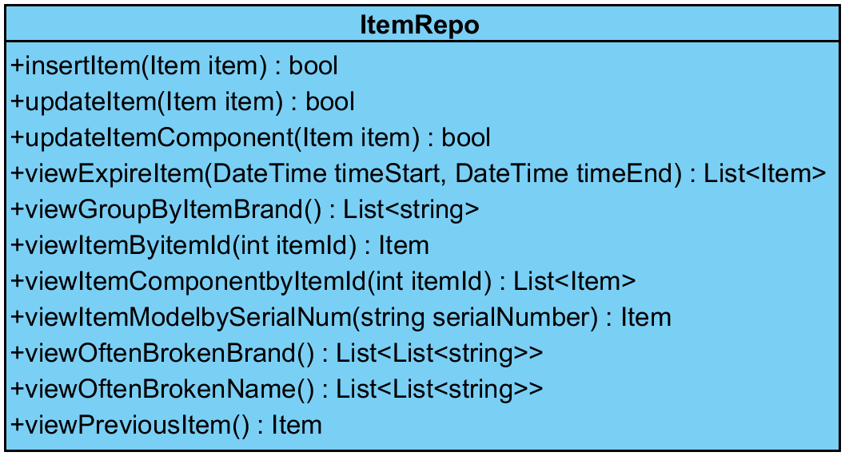

**Description**

This class is a repository class which handles about querying of the Item table in database.

**Method**

|  |  |  |  |  |
| --- | --- | --- | --- | --- |
| No. | Name | Description | Parameters | Return |
|  | insertItem() | This method is used for inserting an IT equipment information to the system. | item:Item | bool |
|  | updateItem() | This method is used for updating an IT equipment information to the system. | item:Item | bool |
|  | updateItemComponent() | This method is used for updating an IT equipment component to the system. | item:Item | bool |
|  | viewExpireItem() | This method is used for getting expire IT equipment information. | timeStart:DateTime, timeEnd:DateTime | List<Item> |
|  | viewGroupByItemBrand() | This method is used for getting all IT equipment brand. |  | List<string> |
|  | viewItemComponentbyItemId() | This method is used for getting all components of IT equipment. | itemId:int | List<Item> |
|  | viewItemModelbySerialNum() | This method is used for getting IT equipment information by identifying from serial number. | serialNumber:string | Item |
|  | viewOftenBrokenBrand() | This method is used for getting IT equipment brand often are broken. | None | List<List<string>> |
|  | viewOftenBrokenName() | This method is used for getting IT equipment name often are broken. | None | List<List<string>> |
|  | viewPreviousItem() | This method is used for getting last IT equipment information that is added to the system. | None | Item |
|  | viewItemByitemId() | This method is used for viewing an IT equipment information by identifying from item id. | itemId:int | Item |

**3.1.15 Class-15. ItemOwnerRepo**

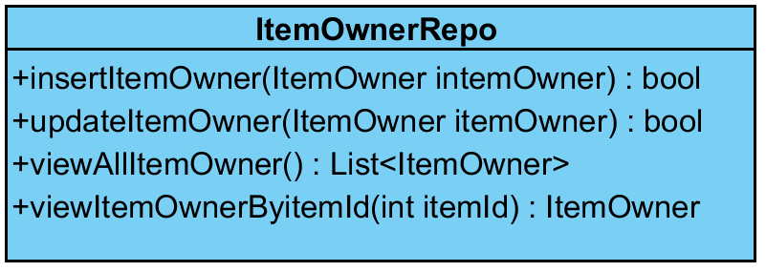

**Description**

This class is a repository class which handles about querying of the ItemOwner table in database.

**Method**

|  |  |  |  |  |
| --- | --- | --- | --- | --- |
| No. | Name | Description | Parameters | Return |
|  | insertItemOwner() | This method is used for inserting item owner information to the system. | itemOwner:ItemOwner | bool |
|  | updateItemOwner() | This method is used for updating item owner information in the system. | itemOwner:ItemOwner | bool |
|  | viewAllItemOwner() | This method is used for viewing all item owner information in the system. | None | List<ItemOwner> |
|  | viewItemOwnerByitemId() | This method is used for viewing item owner information by identifying from item id. | itemId:int | ItemOwner |

**3.1.16 Class-16. ReportRepo**

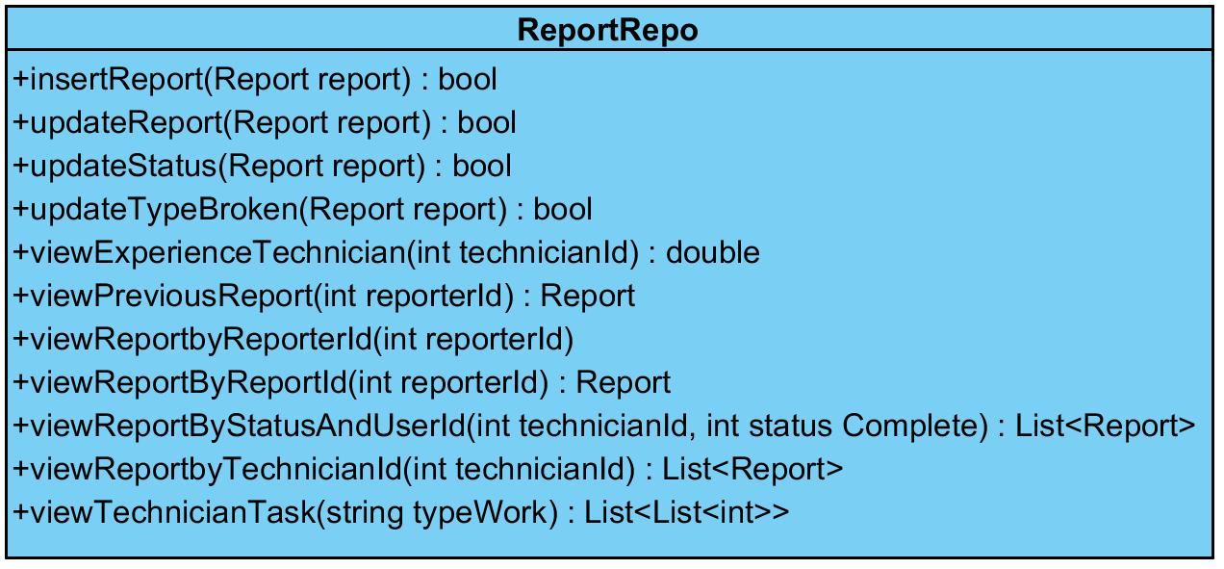

**Description**

This class is a repository class which handles about querying of the Report table in database.

**Method**

|  |  |  |  |  |
| --- | --- | --- | --- | --- |
| No. | Name | Description | Parameters | Return |
|  | insertReport() | This method is used for inserting report information to the system. | report:Report | bool |
|  | updateReport() | This method is used for updating report information in the system. | report:Report | bool |
|  | updateStatus() | This method is used for updating report status in the system. | report:Report | bool |
|  | updateTypeBroken() | This method is used for updating report broken type of IT equipment in the system. | report:Report | bool |
|  | viewExperienceTechnician() | This method is used for viewing time that technician will complete all remaining work. | technicianId:int | double |
|  | viewPreviousReport | This method is used for viewing last report which is added by reporter. | reporterId:int | Report |
|  | viewReportbyReporterId() | This method is used for viewing all report information in the system by identifying from reporter id. | reporterId:int | List<Report> |
|  | viewReportByReportId() | This method is used for viewing report information in the system by identifying from report id. | reportId:int | Report |
|  | viewReportByStatusAndUserId() | This method is used for viewing all report information in the system by identifying from technician id and report status complete | technicianId:int, statusComplete | List<Report> |
|  | viewReportbyTechnicianId)_ | This method is used for viewing all report information in the system by identifying from technician id. | technicianId:int | List<Report> |
|  | viewTechnicianTask() | This method is used for viewing amount of technician and technician id that ever repair in that type work. | typeWork:string | List<List<int>> |

## **3.2 Sequence Diagram**

**3.2.1 Sequence Diagram (SD 1): User can login**

**: This sequence diagram responses to**

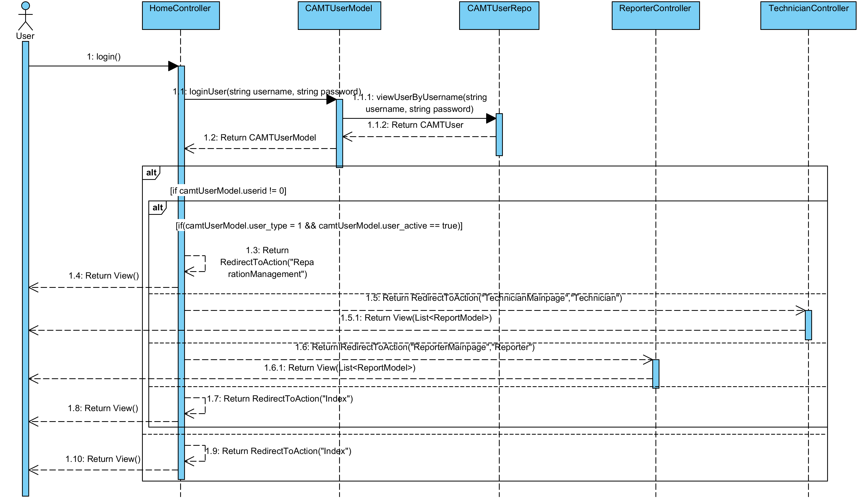

**Relate Classes Implementation**

Class-01 HomeController  
 - Method 1.17, 1.21, 1.27

Class-04 CAMTUserModel

- Method 4.13

Class-13 CAMTUserRepo

- Method 13.8

Class-03 ReporterController

- Method 3.6

Class-02 TechnicianController

- Method 2.10

**3.2.2 Sequence Diagram (SD 2): Administrator can register a technician/reporter account.**

**: This sequence diagram responses to**

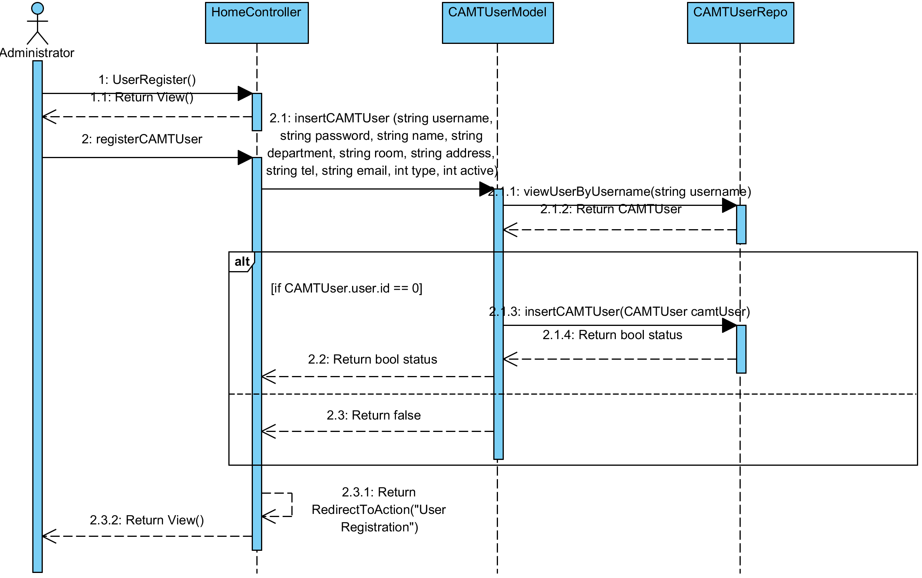

**Relate Classes Implementation**

Class-01 HomeController  
 - Method 1.25, 1.35

Class-04 CAMTUserModel

- Method 4.12

Class-13 CAMTUserRepo

- Method 13.8, 13.1

**3.2.3 Sequence Diagram (SD 3): Administrator can view all technician accounts**

**: This sequence diagram responses to**

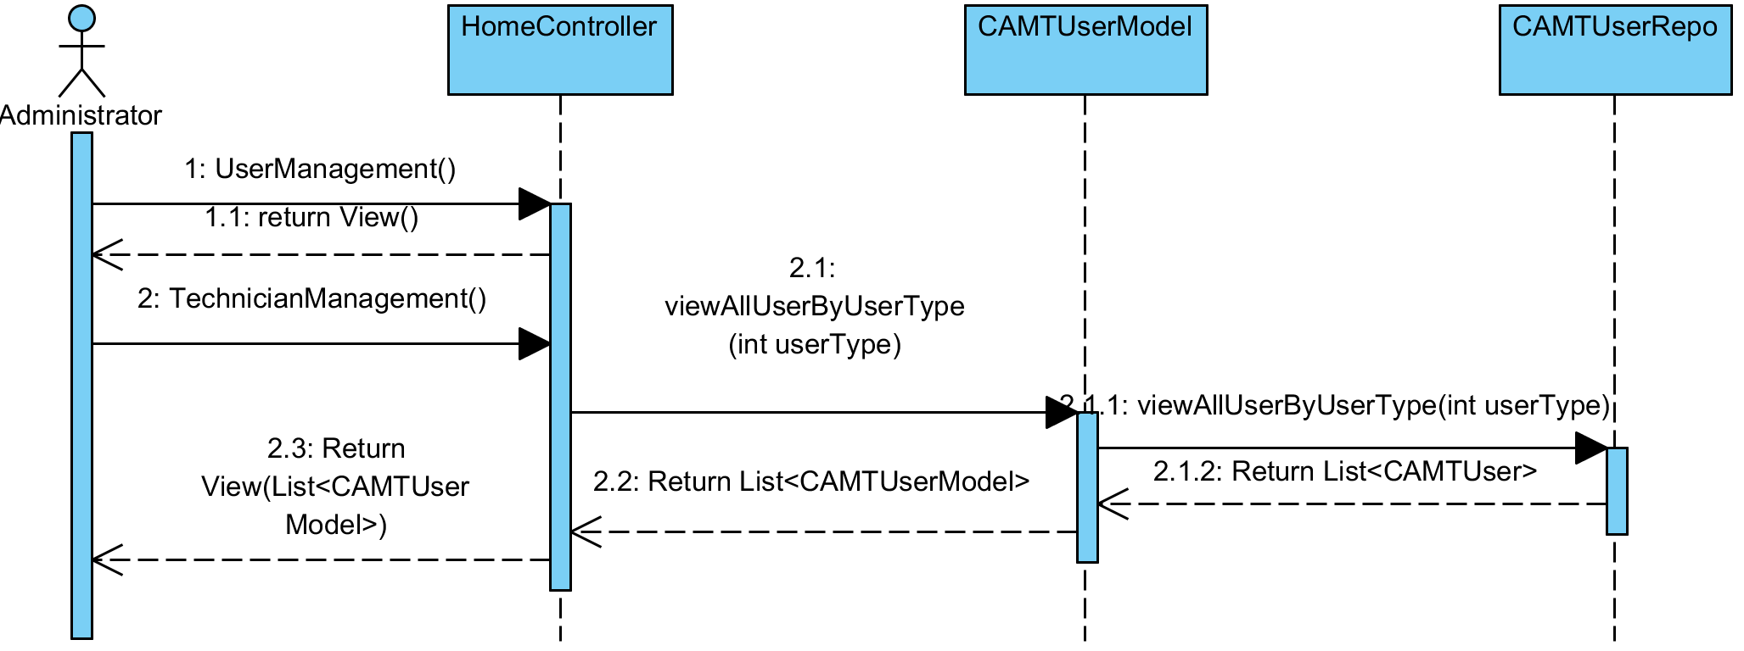

**Relate Classes Implementation**

Class-01 HomeController  
 - Method 1.31, 1.34

Class-04 CAMTUserModel

- Method 4.18

Class-13 CAMTUserRepo

- Method 13.5

**3.2.4 Sequence Diagram (SD 4): Administrator can view all reporter accounts.**

**: This sequence diagram responses to**

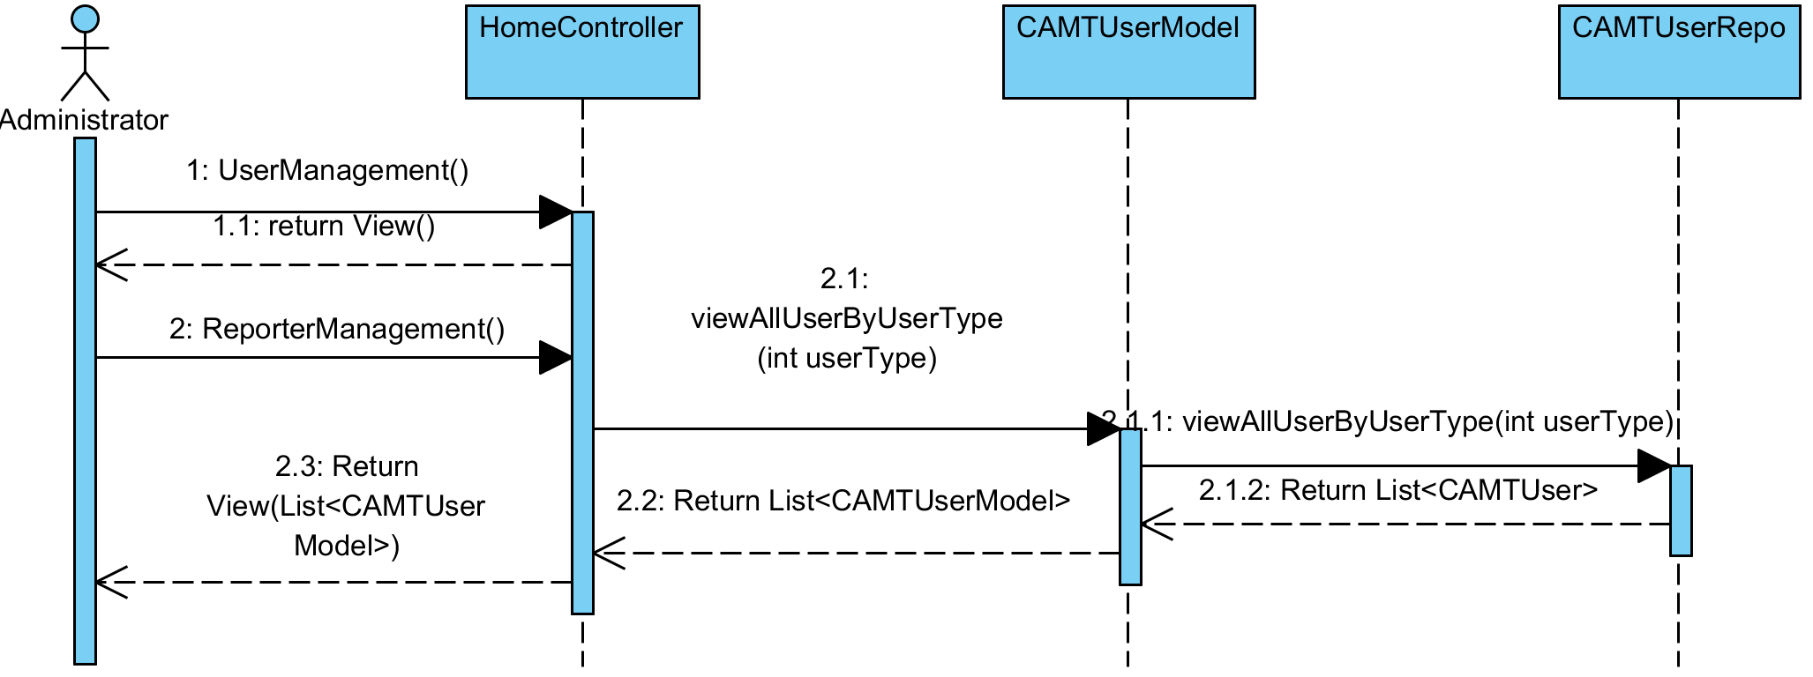

**Relate Classes Implementation**

Class-05 HomeController  
 - Method 5.28, 3.34

Class-04 CAMTUserModel

- Method 4.18

Class-13 CAMTUserRepo

- Method 13.5

**3.2.5 Sequence Diagram (SD 5-1): Administrator can change an active status of technician/ reporter account (Active)**

**: This sequence diagram responses to**

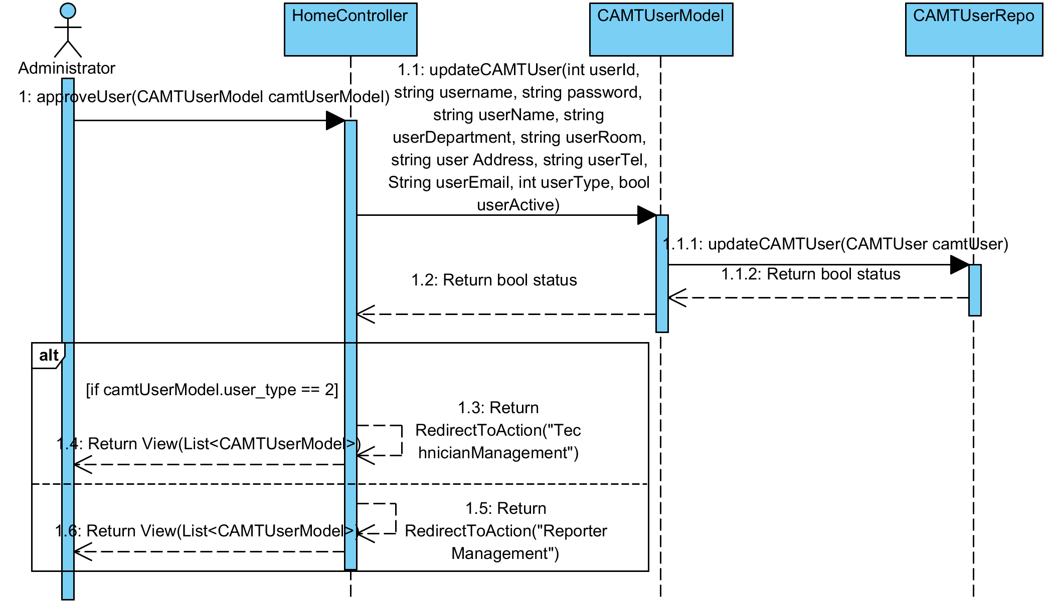

**Relate Classes Implementation**

Class-01 HomeController  
 - Method 1.8, 1.28, 1.31

Class-04 CAMTUserModel

- Method 4.15

Class-13 CAMTUserRepo

- Method 13.3

**3.2.6 Sequence Diagram (SD 5-2): Administrator can change an active status of technician/ reporter account (InActive)**

**: This sequence diagram responses to**

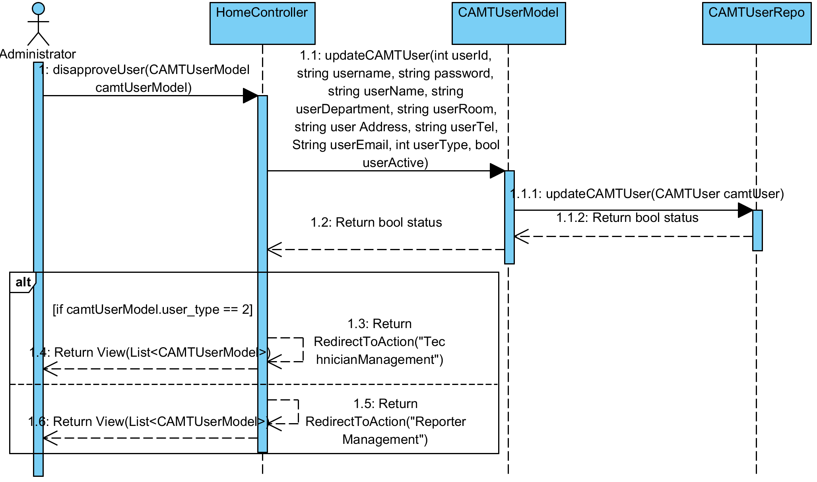

**Relate Classes Implementation**

Class-01 HomeController  
 - Method 1.10, 1.28, 1.31

Class-04 CAMTUserModel

- Method 4.15

Class-13 CAMTUserRepo

- Method 13.3

**3.2.7 Sequence Diagram (SD 6): Administrator can delete a technician/ reporter account**

**: This sequence diagram responses to**

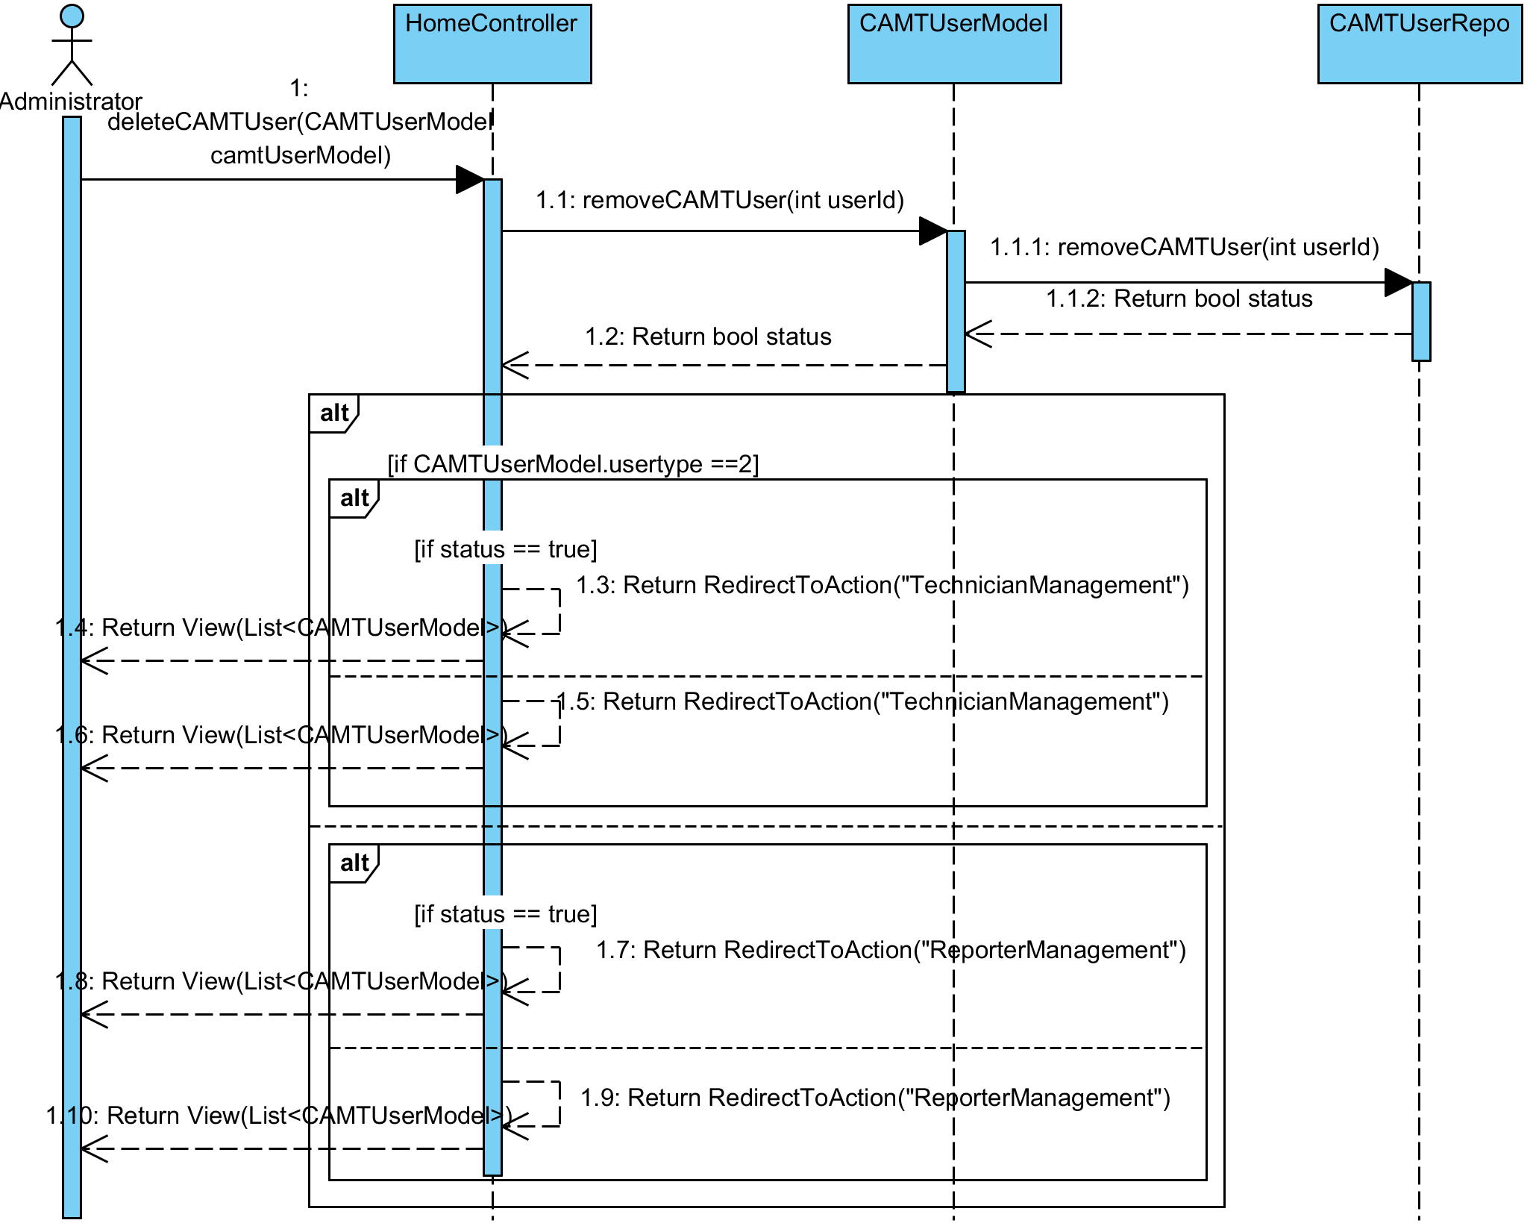

**Relate Classes Implementation**

Class-01 HomeController  
 - Method 1.9, 1.28, 1.31

Class-04 CAMTUserModel

- Method 4.14

Class-13 CAMTUserRepo

- Method 13.2

**3.2.8 Sequence Diagram (SD 7): Administrator can view all IT equipment.**

**: This sequence diagram responses to**

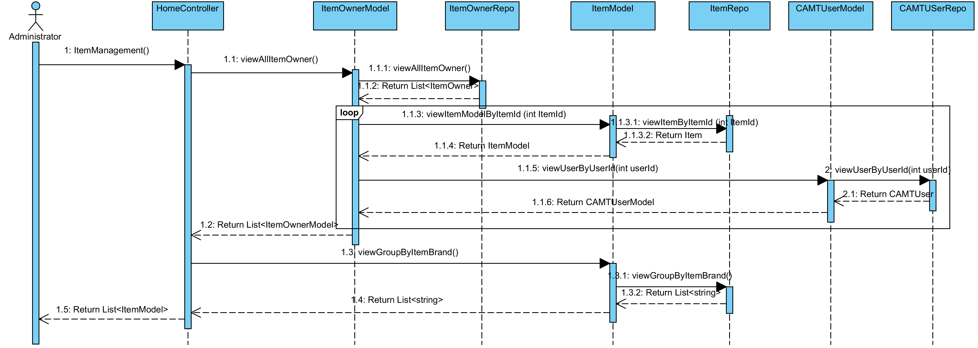

**Relate Classes Implementation**

Class-04 HomeController  
 - Method 4.19

Class-06 ItemOwnerModel

- Method 6.6

Class-15 ItemOwnerRepo

- Method 15.3

Class-05 ItemModel

- Method 5.17, 5.18

Class-14 ItemRepo

- Method 14.11, 14.15

Class-04 CAMTUserModel

- Method 4.19

Class-17 CAMTUserRepo

- Method 13.7

**3.2.9 Sequence Diagram (SD 8): Administrator can add IT equipment**

**: This sequence diagram responses to**

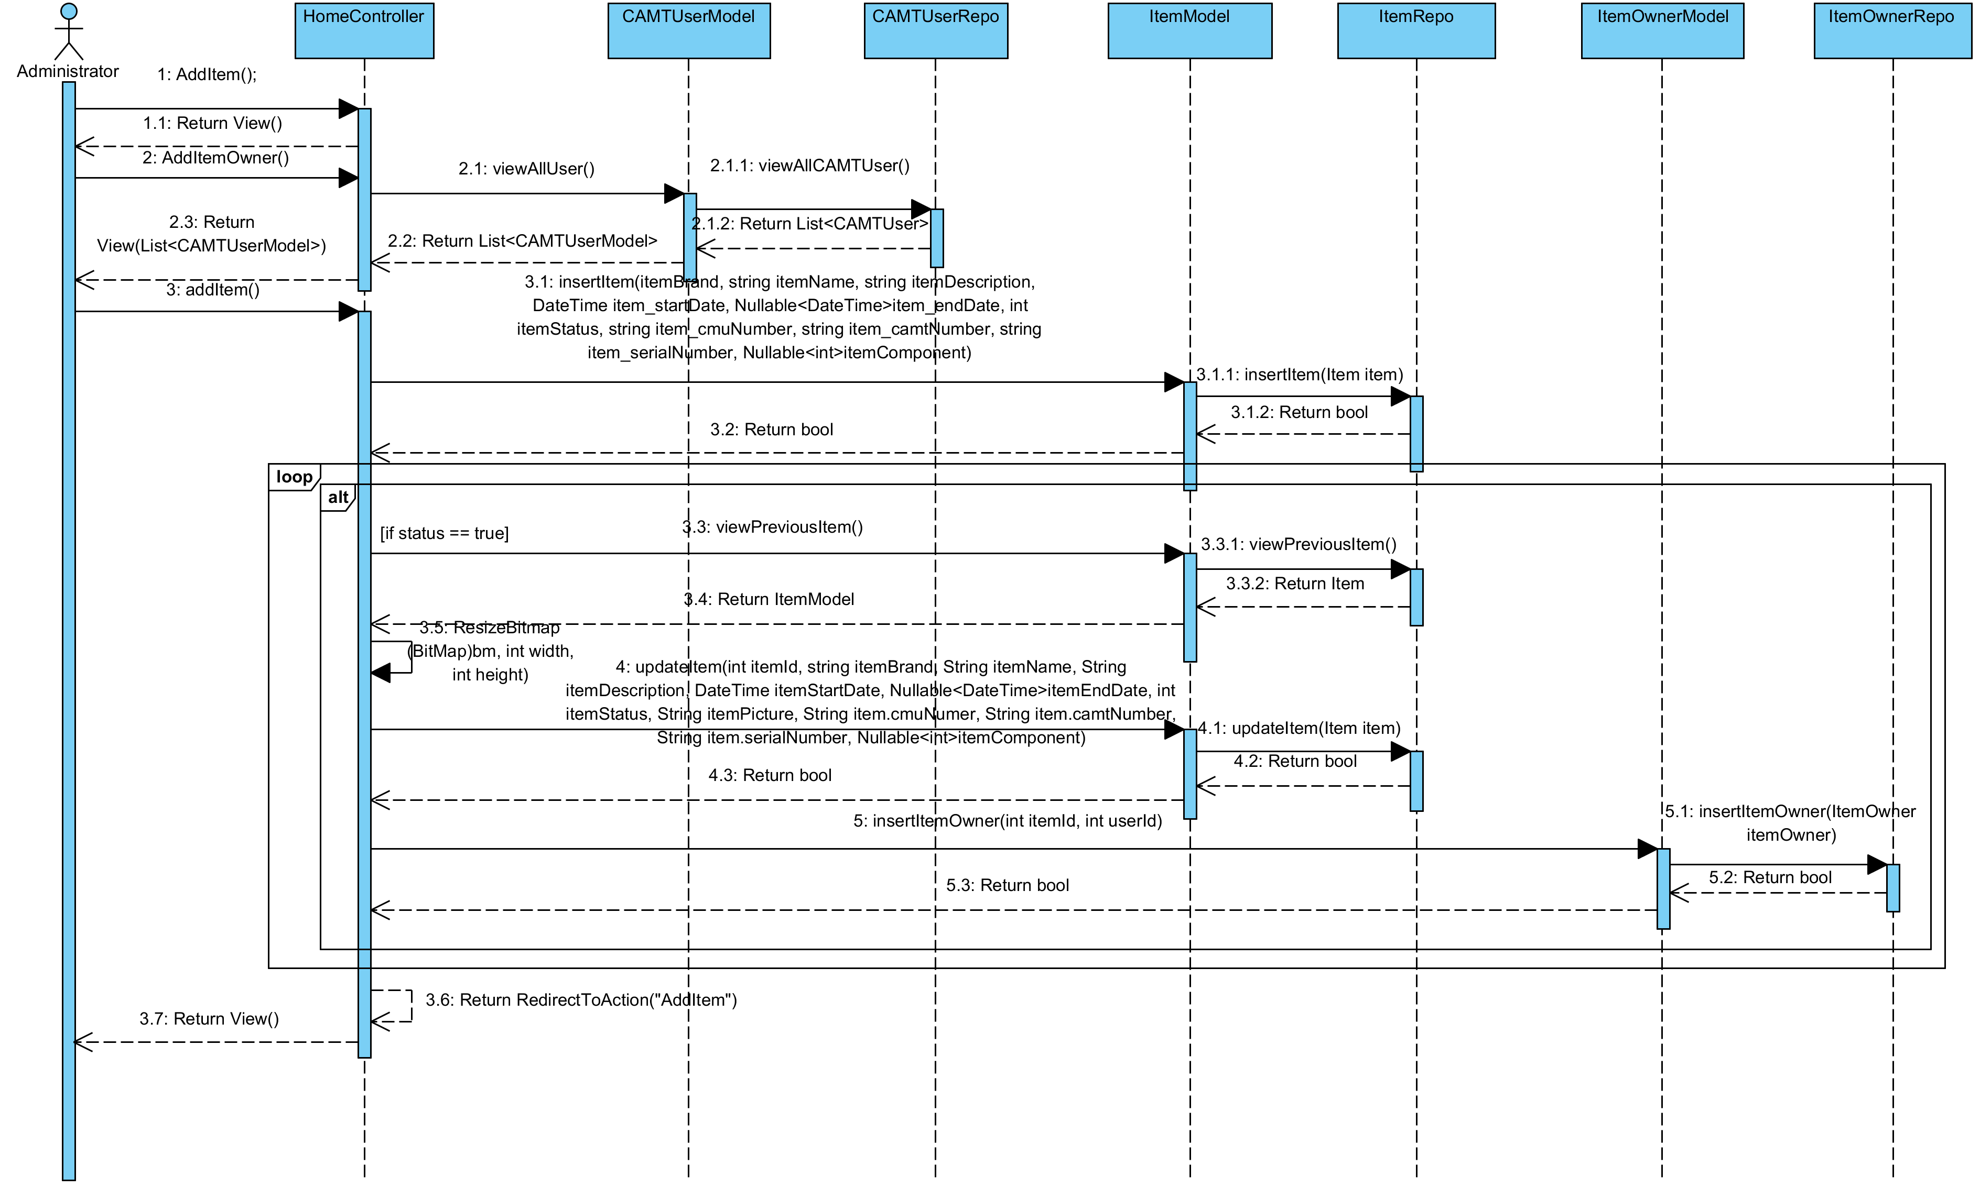

**Relate Classes Implementation**

Class-01 HomeController  
 - Method 1.3, 1.4, 1.5, 1.30

Class-04 CAMTUserModel

- Method 4.17

Class-13 CAMTUserRepo

- Method 13.4

Class-05 ItemModel

- Method 5.13, 5.15, 5.20

Class-14 ItemRepo

- Method 14.1, 14.10, 14.2

Class-06 ItemOwnerModel

- Method 6.4

Class-15 ItemOwnerRepo

- Method 15.1

**3.2.10 Sequence Diagram (SD 9-1.1): Administrator can edit IT equipment.**

**: This sequence diagram responses to**

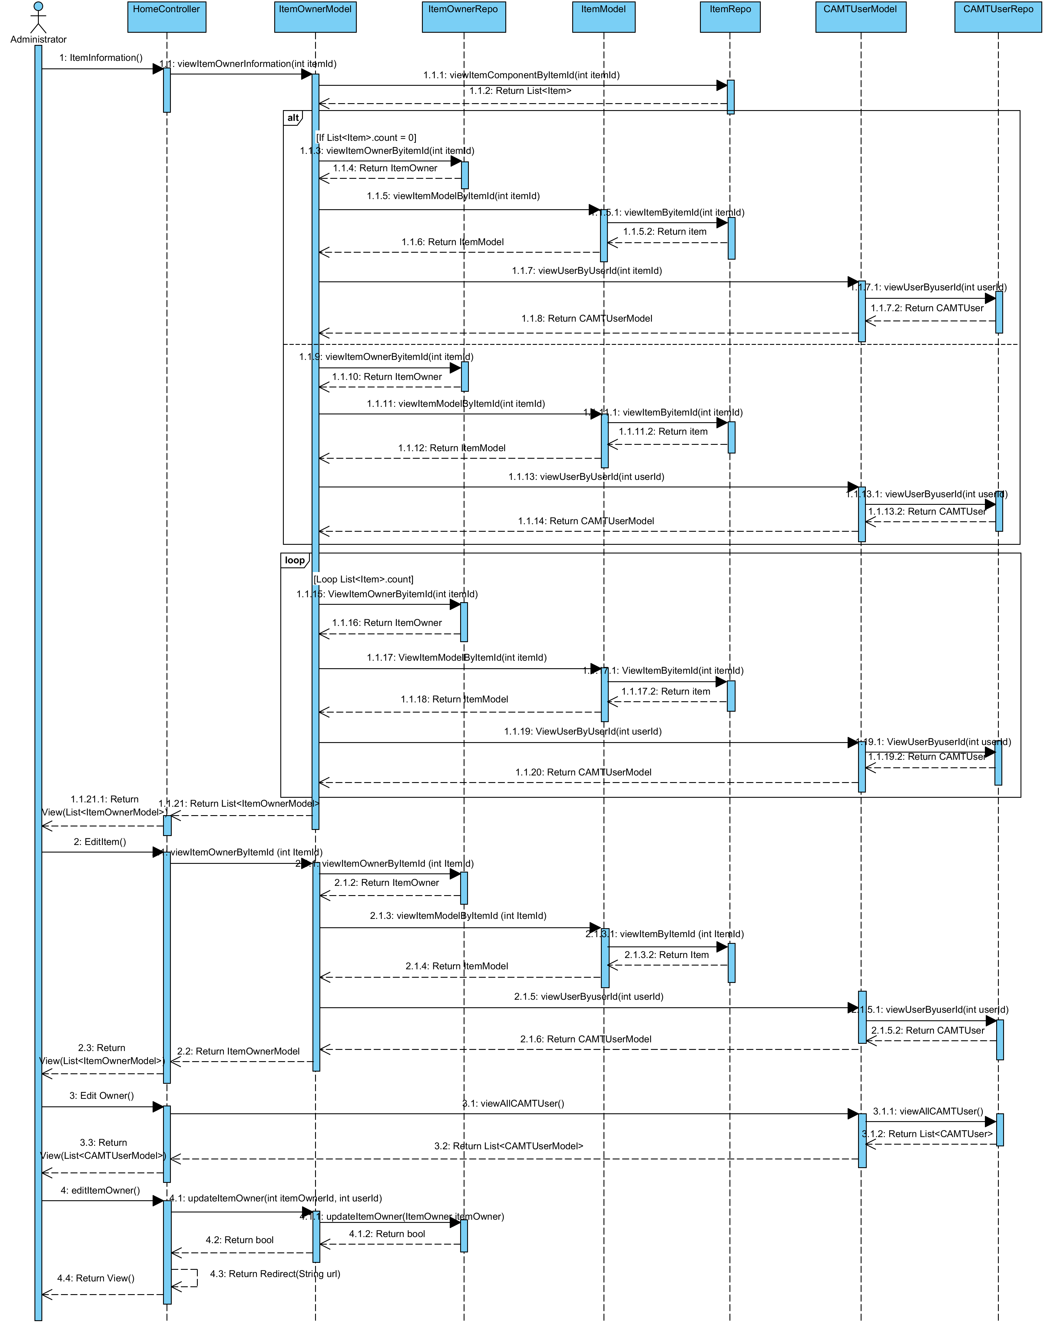

**Relate Classes Implementation**

Class-01 HomeController  
 - Method 1.14, 1.15, 1.16, 1.18

Class-06 ItemOwnerModel

- Method 6.8, 6.7, 6.5

Class-15 ItemOwnerRepo

- Method 15.4, 15.2

Class-05 ItemModel

- Method 5.18

Class-14 ItemRepo

- Method 14.6, 14.11

Class-04 CAMTUserModel

- Method 4.19, 4.17

Class-13 CAMTUserRepo

- Method 13.7, 13.4

**3.2.11 Sequence Diagram (SD 9-1.2): Administrator can edit IT equipment.**

**: This sequence diagram responses to**

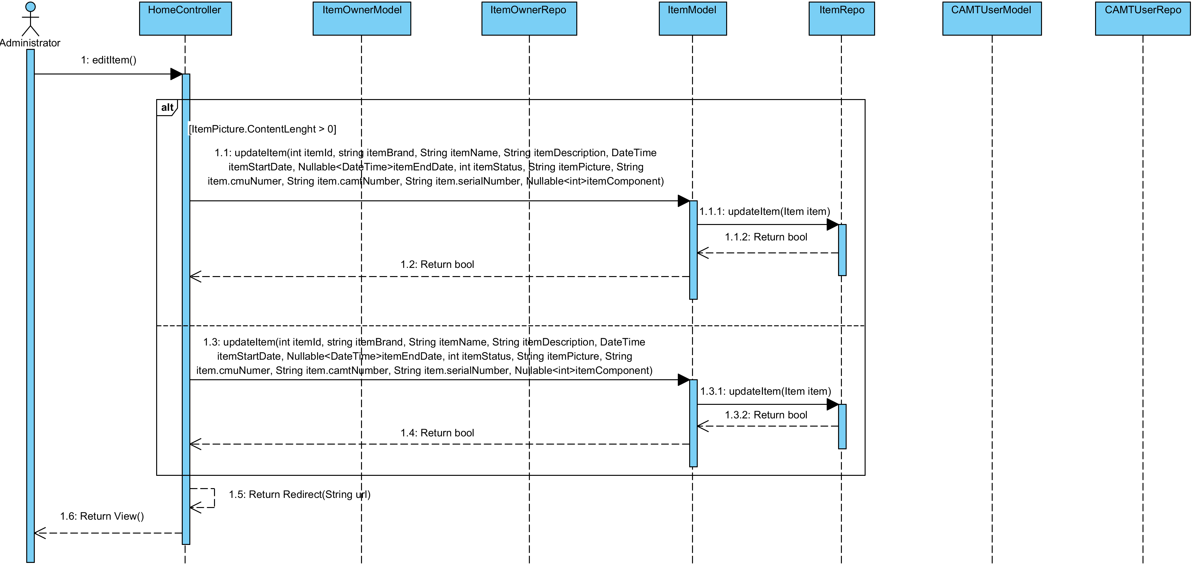

**Relate Classes Implementation**

Class-01 HomeController  
 - Method 1.13

Class-06 ItemOwnerModel

Class-15 ItemOwnerRepo

Class-05 ItemModel

- Method 5.15

Class-14 ItemRepo

- Method 14.2

Class-04 CAMTUserModel

Class-13 CAMTUserRepo

**3.2.12 Sequence Diagram (SD 9-2): Administrator can edit IT equipment (Remove IT equipment component).**

**: This sequence diagram responses to**

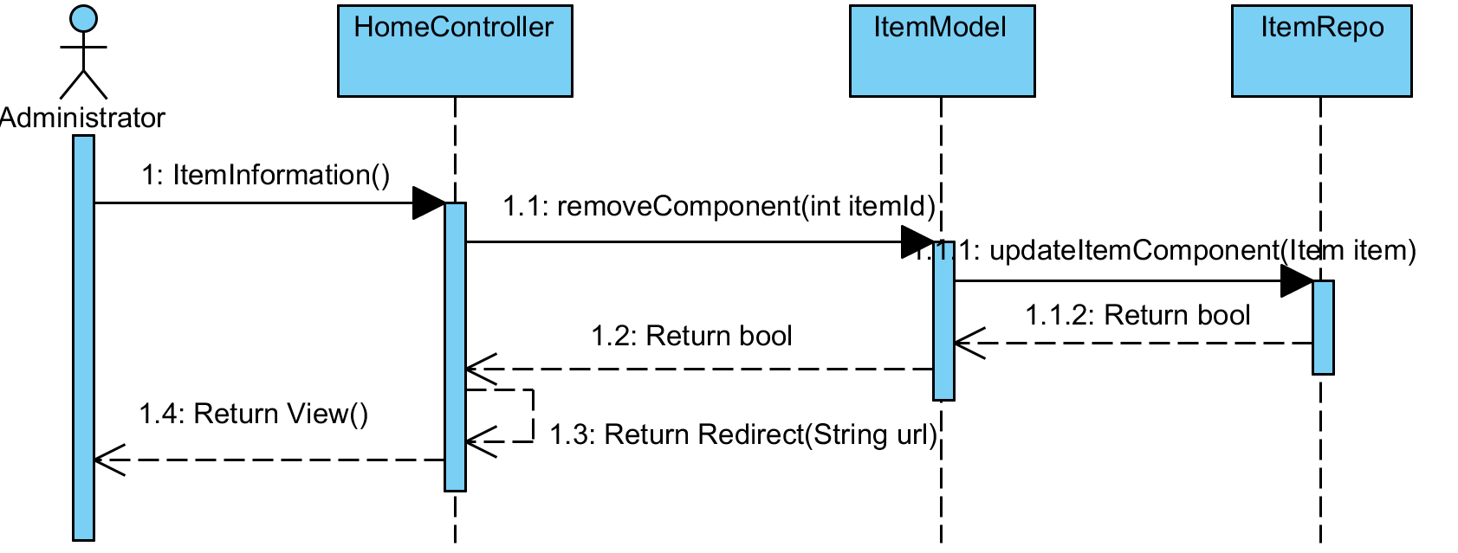

**Relate Classes Implementation**

Class-01 HomeController  
 - Method 1.18

Class-05 ItemModel

- Method 5.14

Class-14 ItemRepo

- Method 14.3

**3.2.12 Sequence Diagram (SD 9-3): Administrator can edit IT equipment (Add IT equipment component).**

**: This sequence diagram responses to**

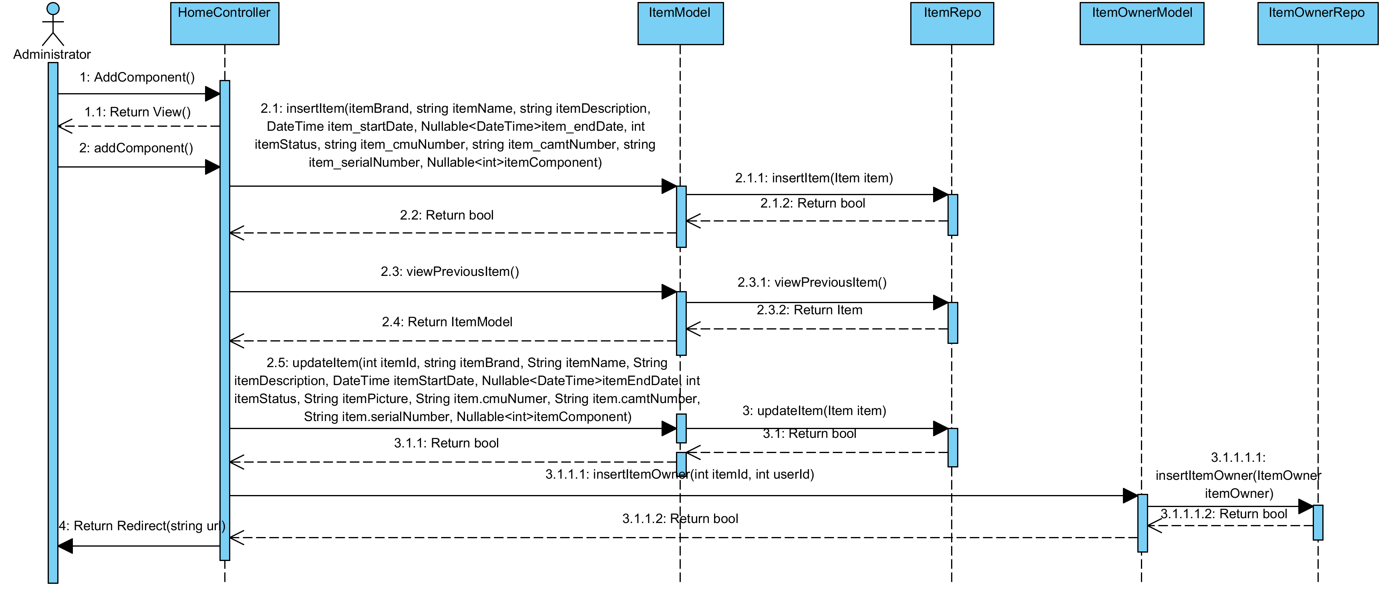

**Relate Classes Implementation**

Class-01 HomeController  
 - Method 1.1, 1.2

Class-05 ItemModel

- Method 5.13, 5.15, 5.20

Class-14 ItemRepo

- Method 14.1, 14.10, 14.2

Class-06 ItemOwnerModel

- Method 6.4

Class-15 ItemOwnerRepo

- Method 15.1

**3.2.13 Sequence Diagram (SD 10): Administrator can view IT equipment that expire.**

**: This sequence diagram responses to**

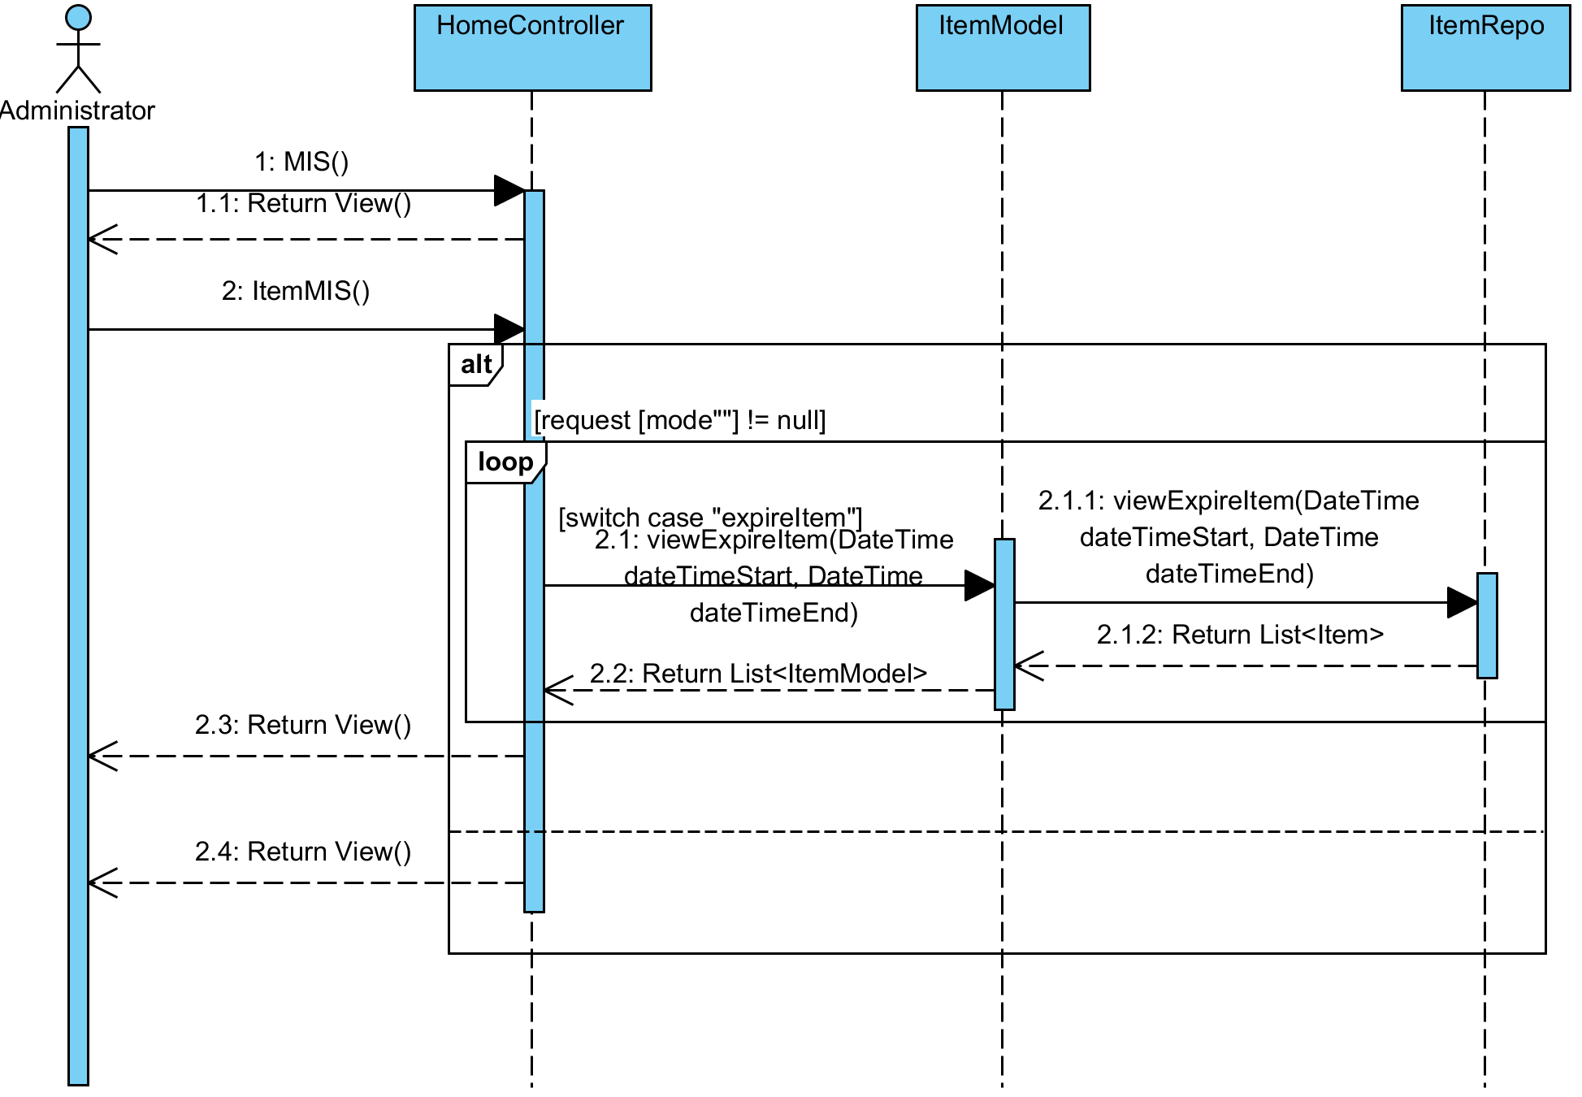

**Relate Classes Implementation**

Class-01 HomeController  
 - Method 1.23, 1.20

Class-05 ItemModel

- Method 5.16

Class-14 ItemRepo

- Method 14.4

**3.2.14 Sequence Diagram (SD 11): Administrator can view IT equipment that are often broken**

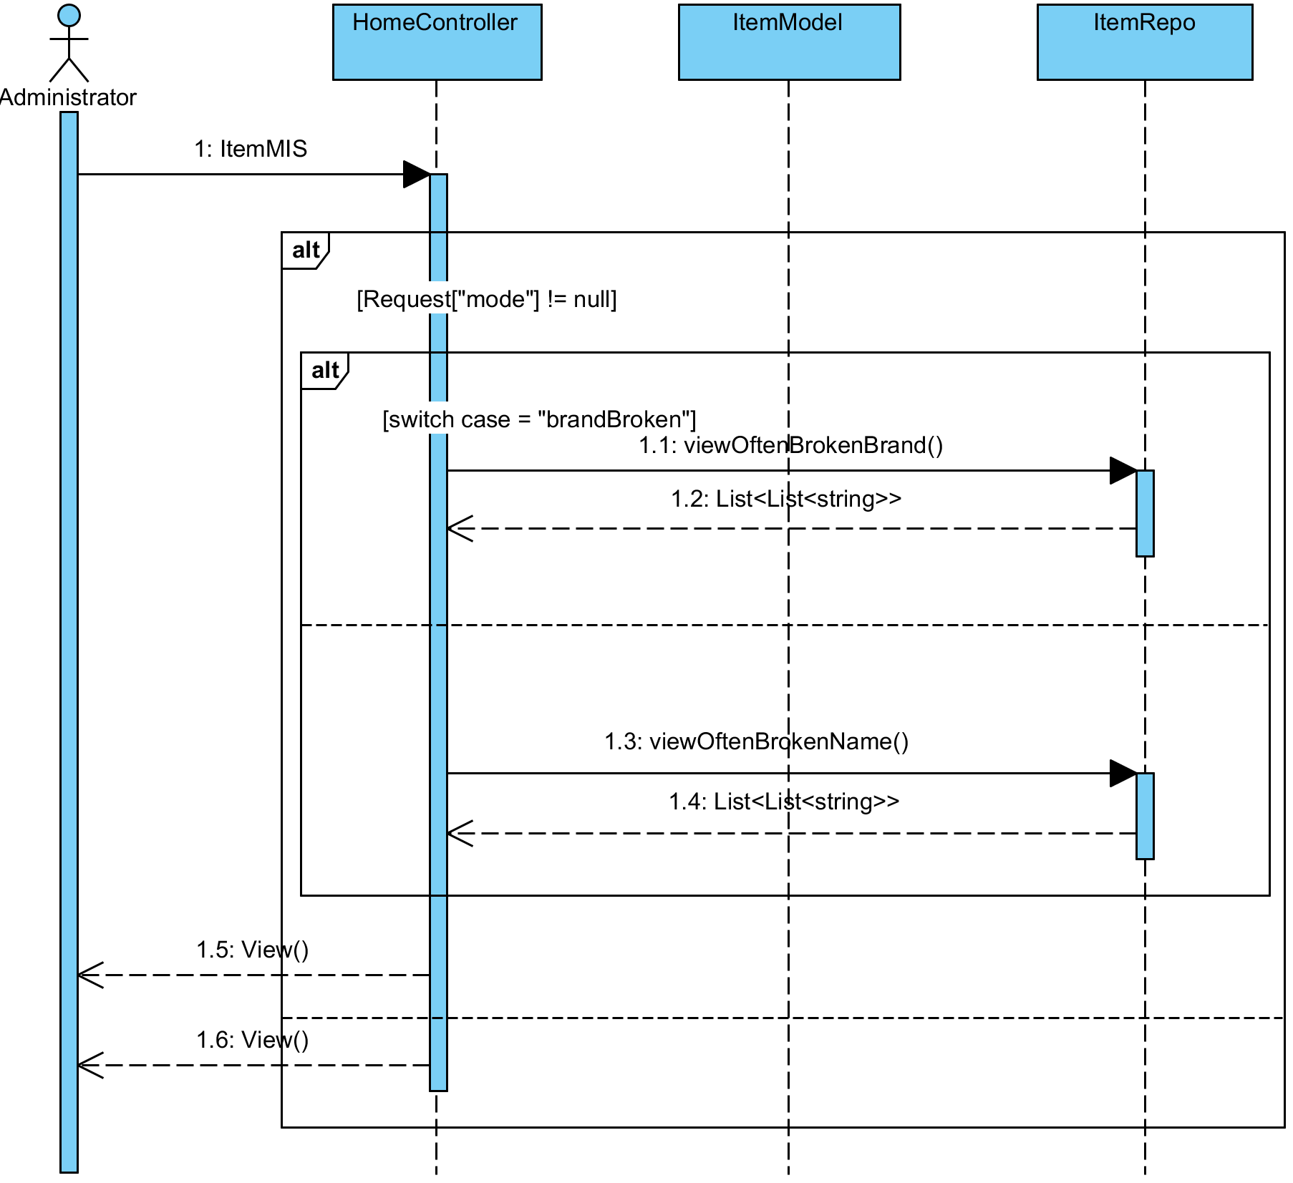**: This sequence diagram responses to**

**Relate Classes Implementation**

Class-01 HomeController  
 - Method 1.20

Class-05 ItemModel

- Method

Class-14 ItemRepo

- Method 14.8, 14.9

**3.2.15 Sequence Diagram (SD 12): Administrator can view an IT equipment Information**

**: This sequence diagram response**

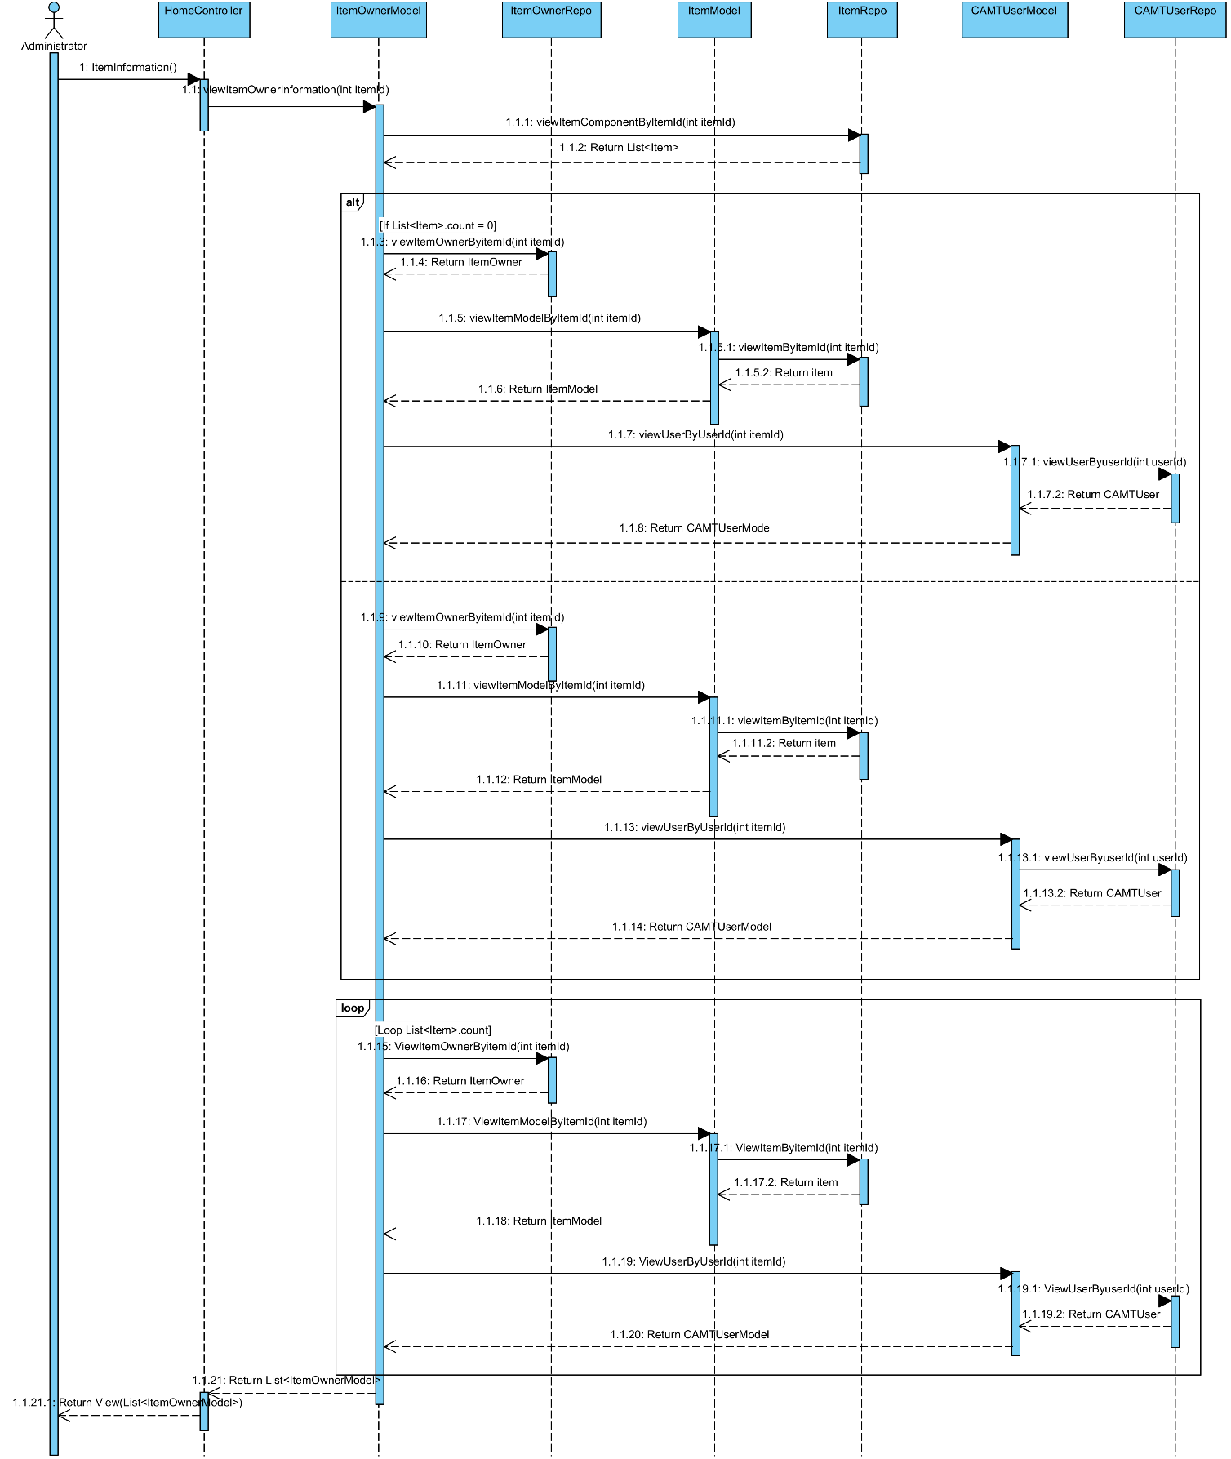

**Relate Classes Implementation**

Class-01 HomeController  
 - Method 1.18

Class-06 ItemOwnerModel

- Method 6.8

Class-15 ItemOwnerRepo

- Method 15.4

Class-05 ItemModel

- Method 5.18

Class-14 ItemRepo

- Method 14.6, 14.11

Class-04 CAMTUserModel

- Method 4.19

Class-13 CAMTUserRepo

- Method 13.7

**3.2.18 Sequence Diagram (SD 13.1): Administrator can define type of broken of IT equipment**

**: This sequence diagram responses to**

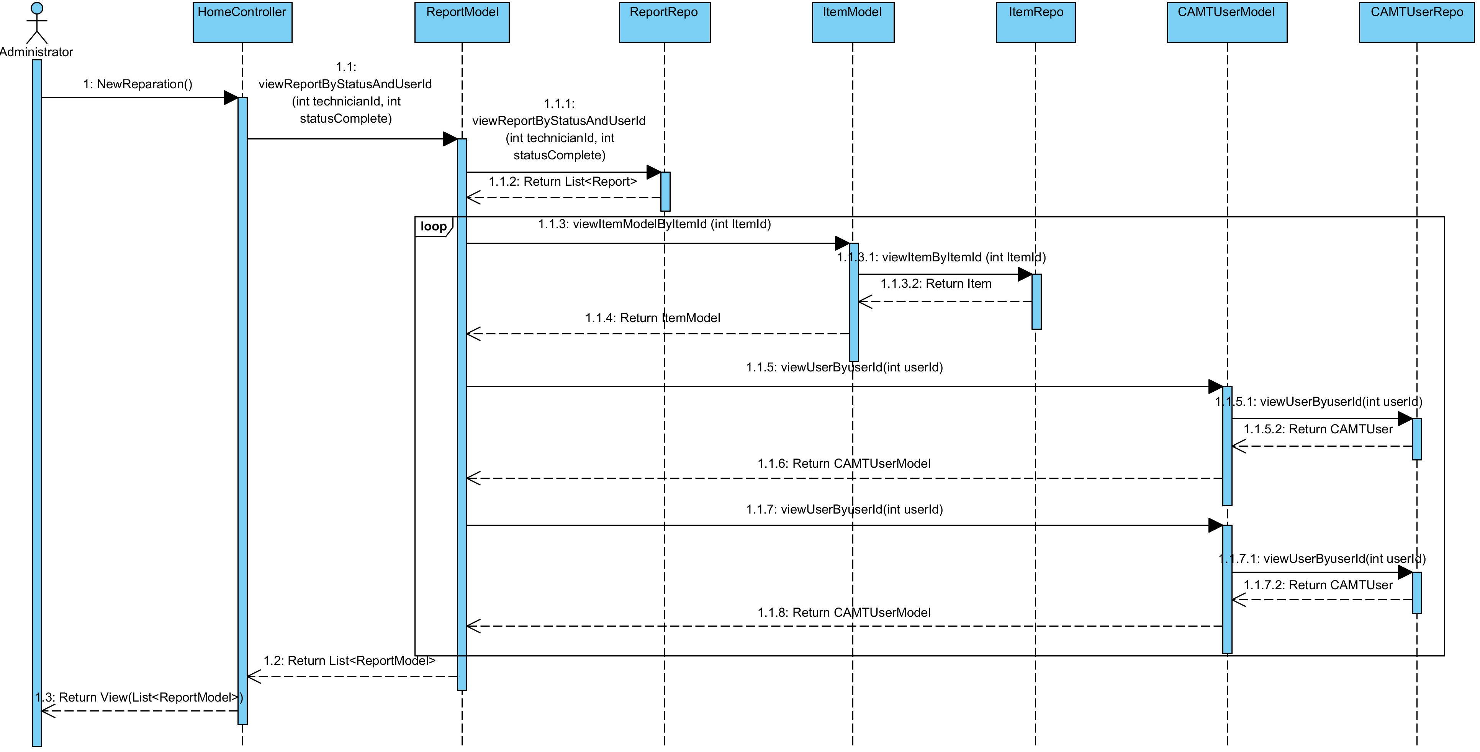

**Relate Classes Implementation**

Class-01 HomeController  
 - Method 1.24

Class-07 ReportModel

- Method 7.23

Class-16 ReportRepo

- Method 16.9

Class-05 ItemModel

- Method 5.18

Class-14 ItemRepo

- Method 14.11

Class-04 CAMTUserModel

- Method 4.19

Class-13 CAMTUserRepo

- Method 13.7

**3.2.19 Sequence Diagram (SD 13.2): Administrator can define type of broken of IT equipment**

**: This sequence diagram responses to**

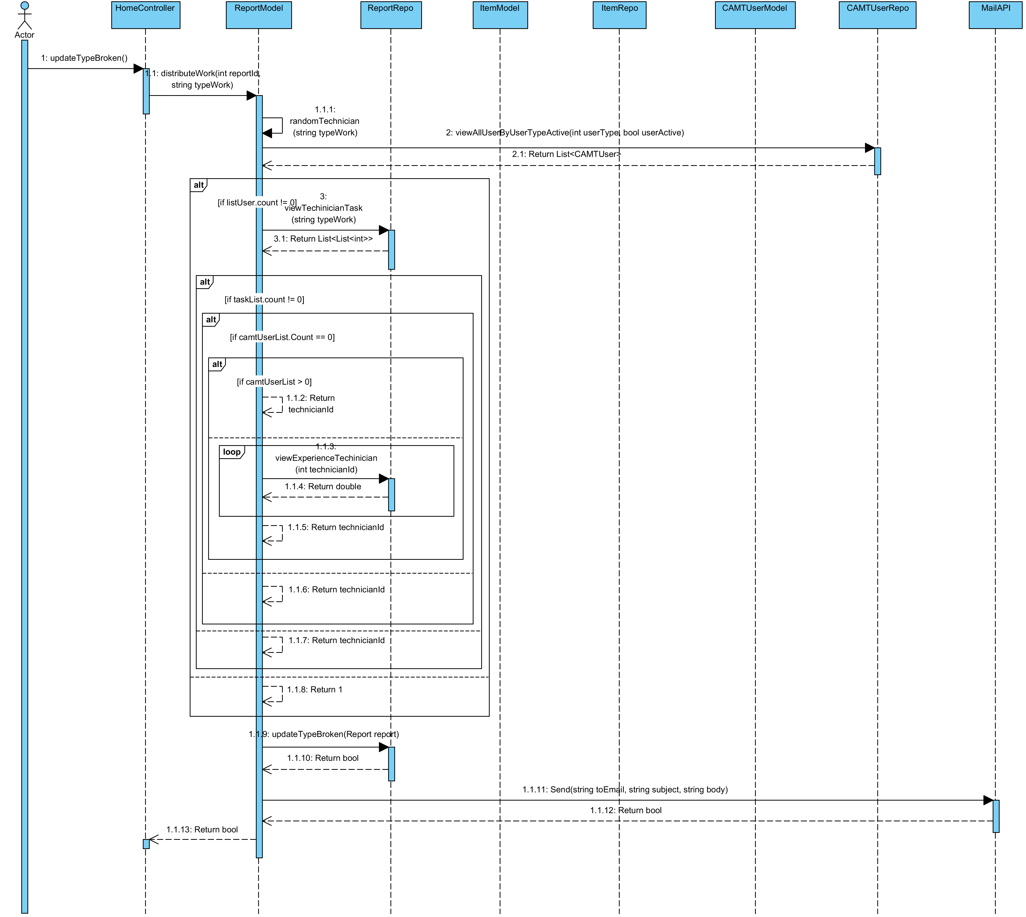

**Relate Classes Implementation**

Class-01 HomeController  
 - Method 1.33

Class-07 ReportModel

- Method 7.13, 7.15

Class-16 ReportRepo

- Method 16.11, 16.5, 16.4

Class-05 ItemModel

Class-14 ItemRepo

Class-04 CAMTUserModel

Class-13 CAMTUserRepo

- Method 13.6

Class-08 MailAPI

- Method 8.9

**3.2.20 Sequence Diagram (SD 13.3): Administrator can define type of broken of IT equipment**

**: This sequence diagram responses to**

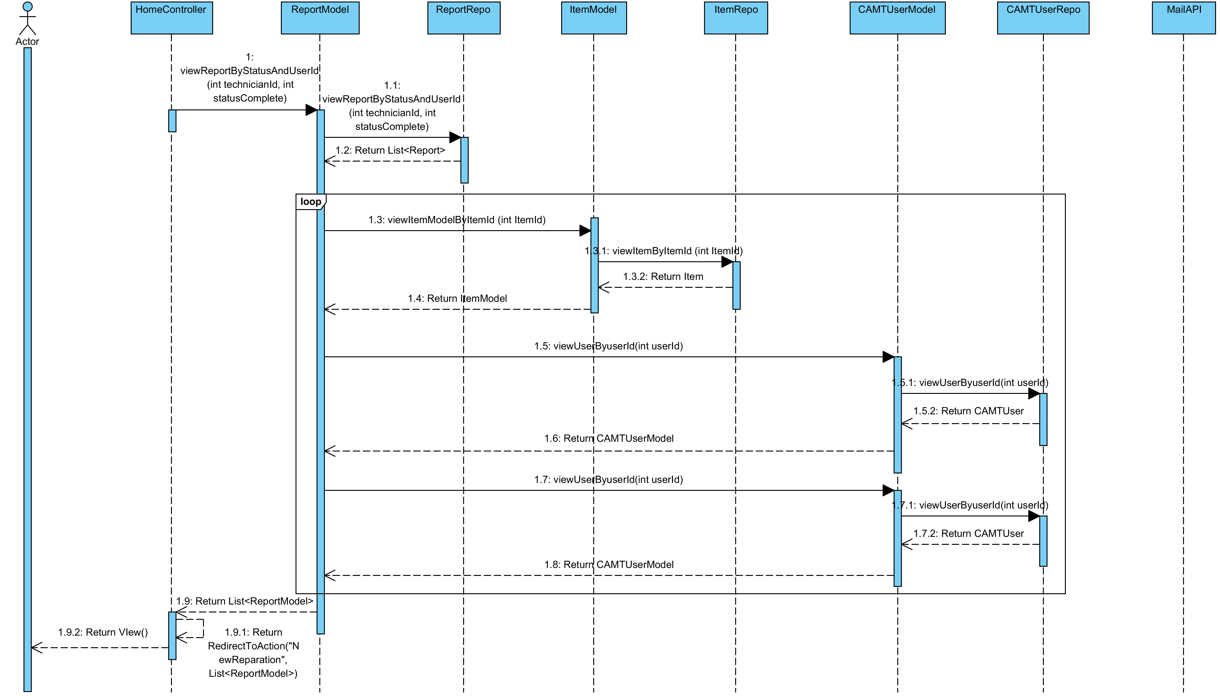

**Relate Classes Implementation**

Class-01 HomeController

- Method 1.24

Class-07 ReportModel

- Method 7.23

Class-16 ReportRepo

- Method 16.9

Class-05 ItemModel

- Method 5.18

Class-14 ItemRepo

- Method 14.11

Class-04 CAMTUserModel

- Method 4.19

Class-13 CAMTUserRepo

- Method 13.4

Class-8 MailAPI

**3.2.21 Sequence Diagram (SD 14): Administrator can view all repair tasks of a technician**

**: This sequence diagram responses to**

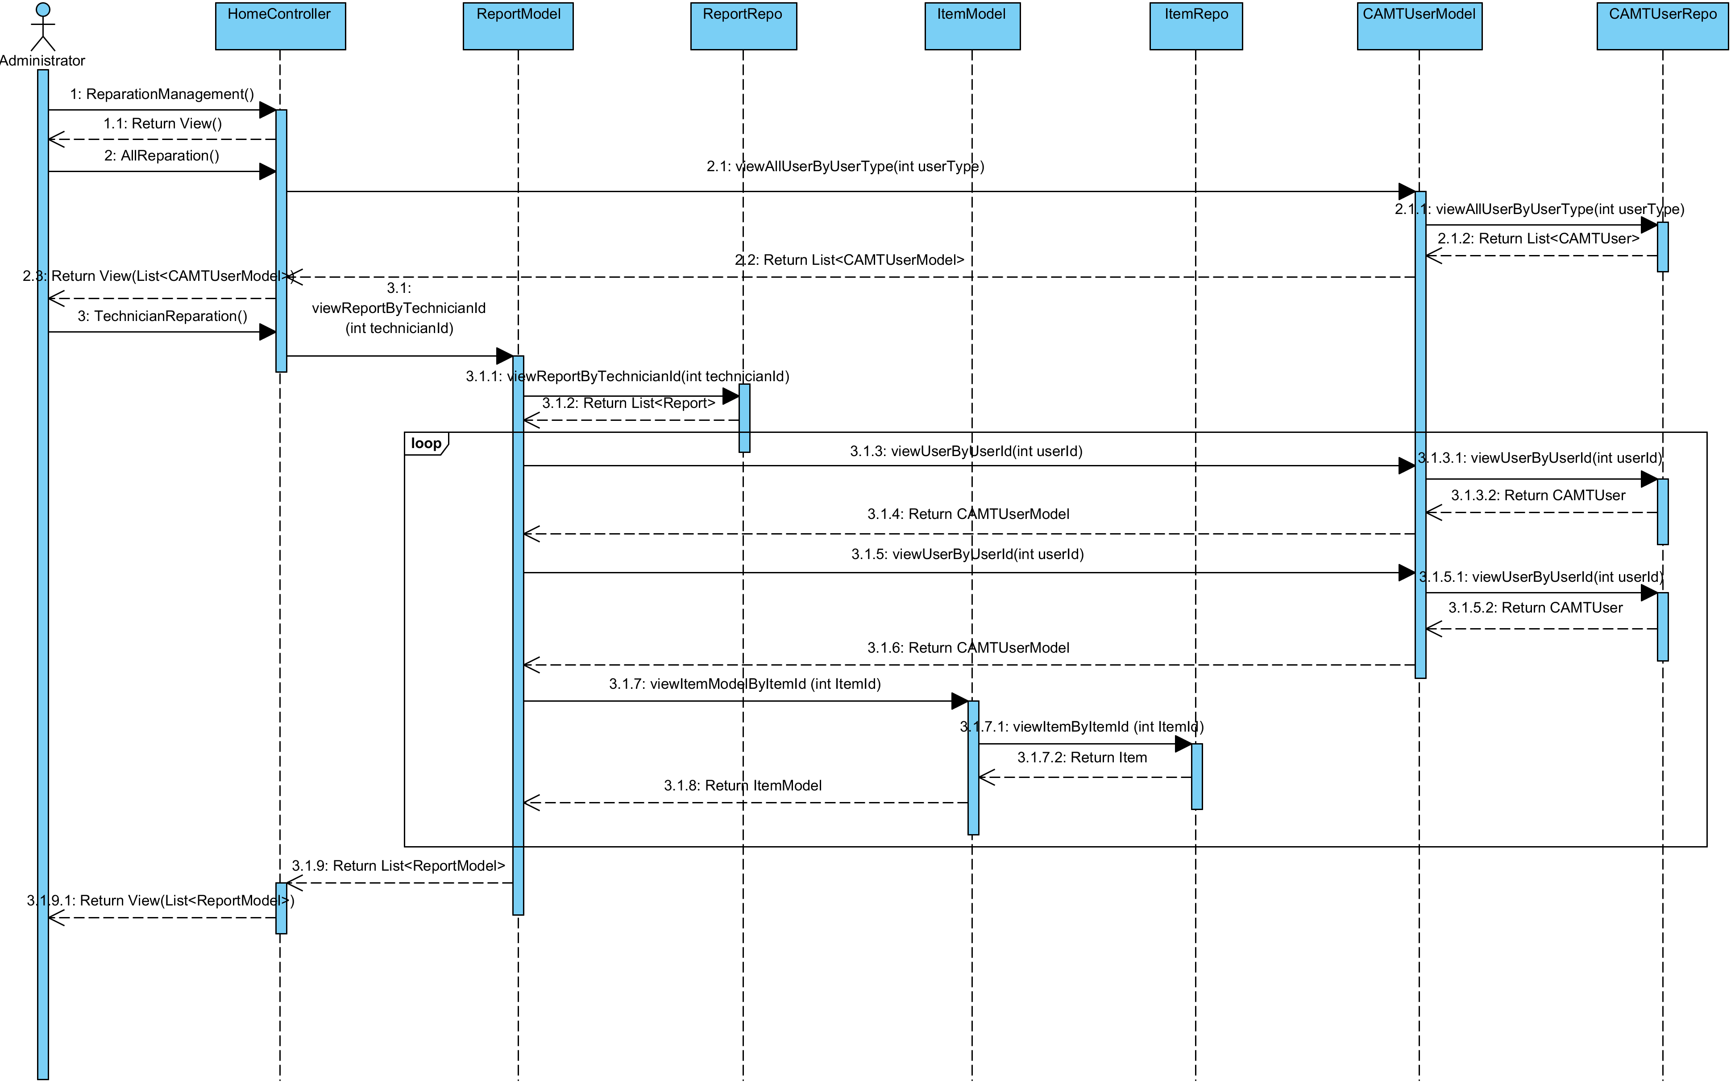

**Relate Classes Implementation**

Class-01 HomeController

- Method 1.27, 1.7, 1.32

Class-07 ReportModel

- Method 7.24

Class-16 ReportRepo

- Method 16.10

Class-05 ItemModel

- Method 5.18

Class-14 ItemRepo

- Method 14.11

Class-04 CAMTUserModel

- Method 4.18, 4.19

Class-13 CAMTUserRepo

- Method 13.5, 13.7

**3.2.22 Sequence Diagram (SD 15): Administrator can request to distribute repair tasks again to the system.**

**: This sequence diagram responses to**

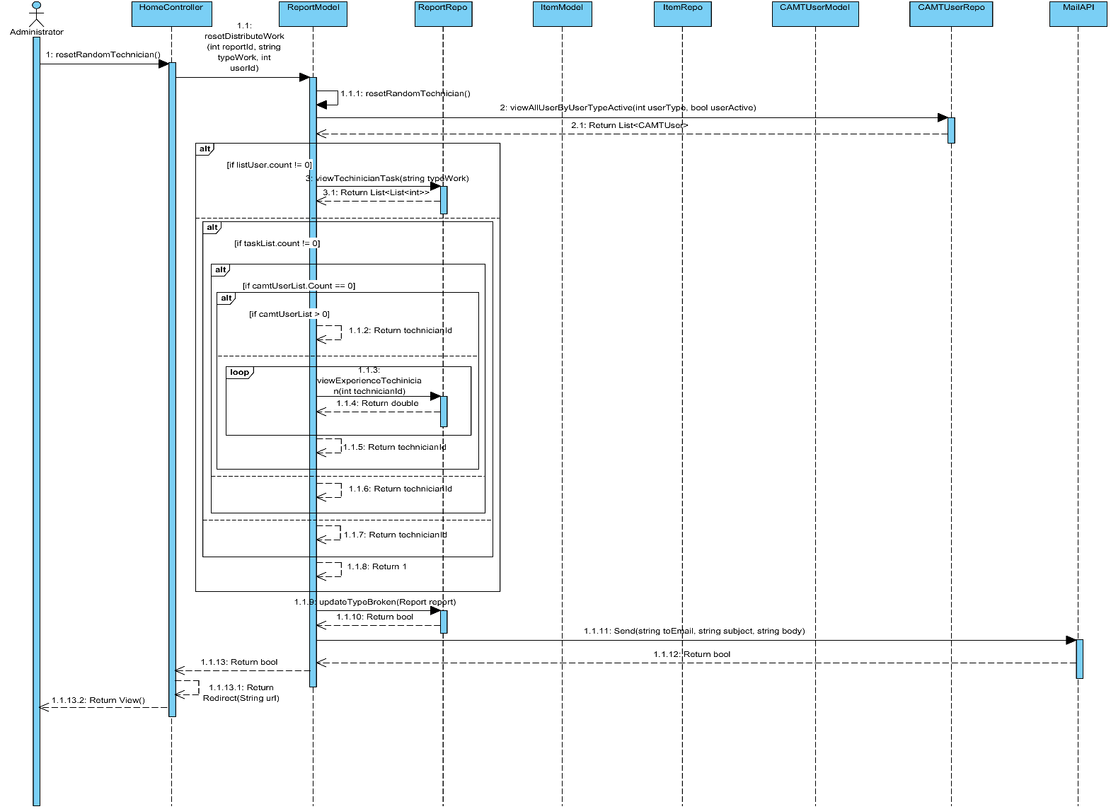

**Relate Classes Implementation**

Class-01 HomeController

- Method 1.29

Class-07 ReportModel

- Method 7.16, 7.17

Class-16 ReportRepo

- Method 16.11, 16.5, 16.4

Class-05 ItemModel

Class-14 ItemRepo

Class-04 CAMTUserModel

Class-13 CAMTUserRepo

- Method 13.6

Class-08 MailAPI

- Method 8.9

**3.2.23 Sequence Diagram (SD 16-1): Administrator can update his account information (update basic information)**

**: This sequence diagram responses to**

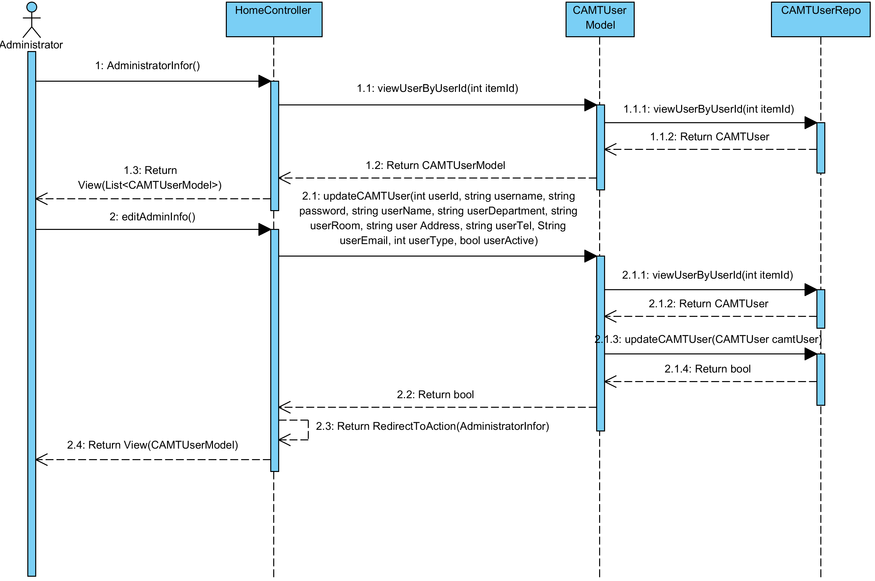

**Relate Classes Implementation**

Class-01 HomeController

- Method 1.6, 1.11

Class-04 CAMTUserModel

- Method 4.19, 4.15

Class-13 CAMTUserRepo

- Method 13.7, 13.3

**3.2.24 Sequence Diagram (SD 16-2): Administrator can update his account information (update password)**

**: This sequence diagram responses to**

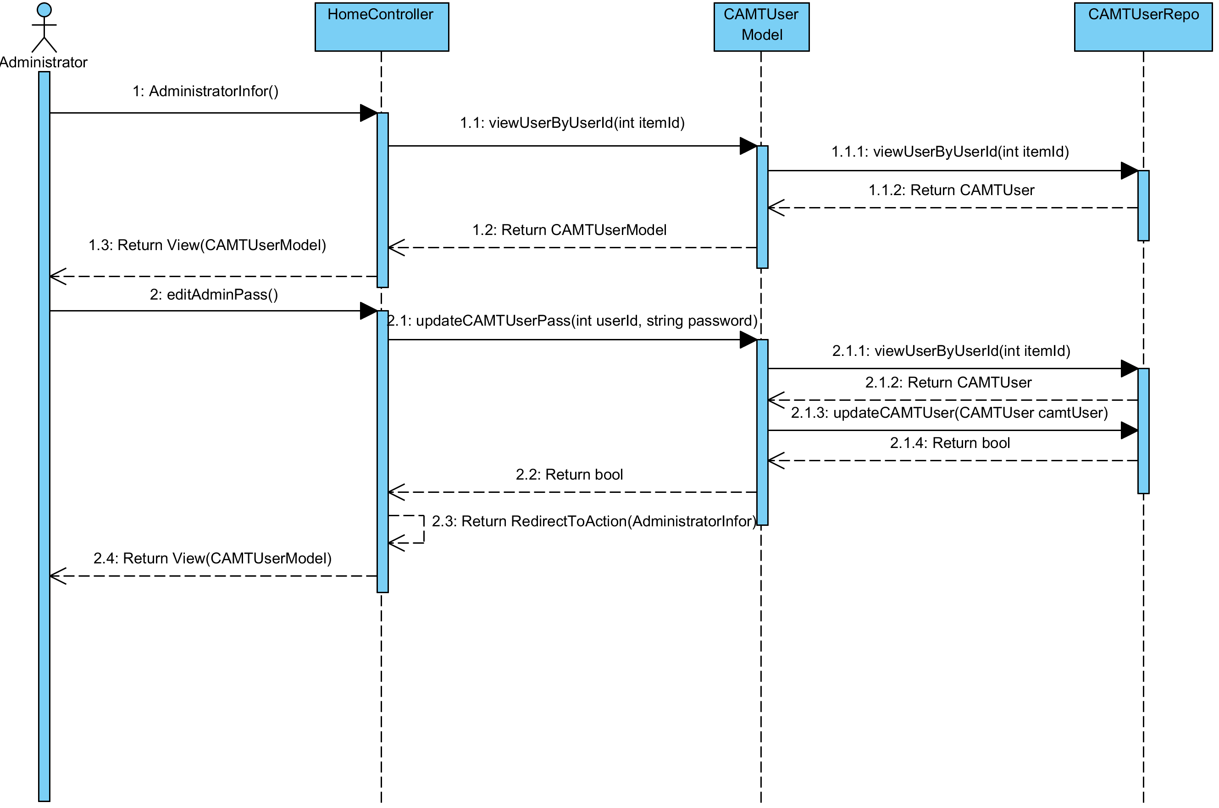

**Relate Classes Implementation**

Class-01 HomeController

- Method 1.6, 1.12

Class-04 CAMTUserModel

- Method 4.19, 4.16

Class-13 CAMTUserRepo

- Method 13.7, 13.3

**3.2.25 Sequence Diagram (SD 17): Technician can view all new repair task information**

**: This sequence diagram responses to**

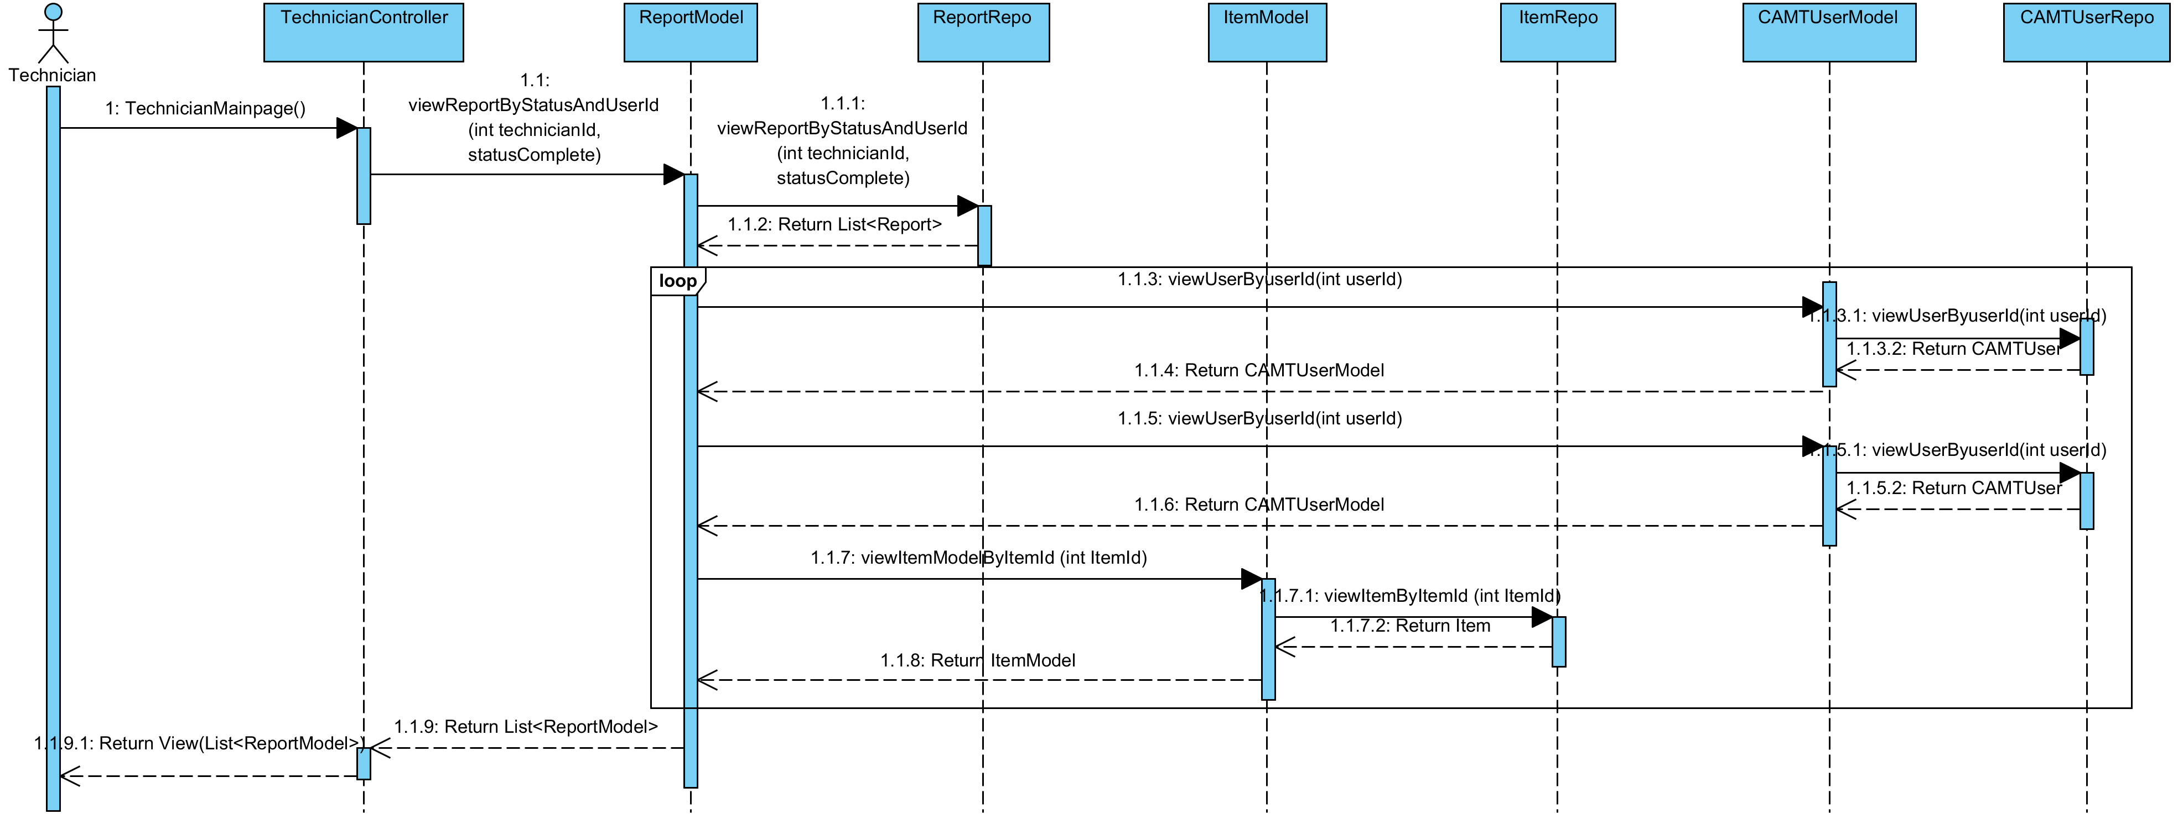

**Relate Classes Implementation**

Class-02 TechnicianController

- Method 2.10

Class-7 ReportModel

- Method 7.23

Class-16 ReportRepo

- Method 16.9

Class-05 ItemModel

- Method 5.18

Class-14 ItemRepo

- Method 14.11

Class-04 CAMTUserModel

- Method 4.19

Class-13 CAMTUserRepo

- Method 13.7

**3.2.26 Sequence Diagram (SD 18): Technician can update repair task status**

**: This sequence diagram responses to**

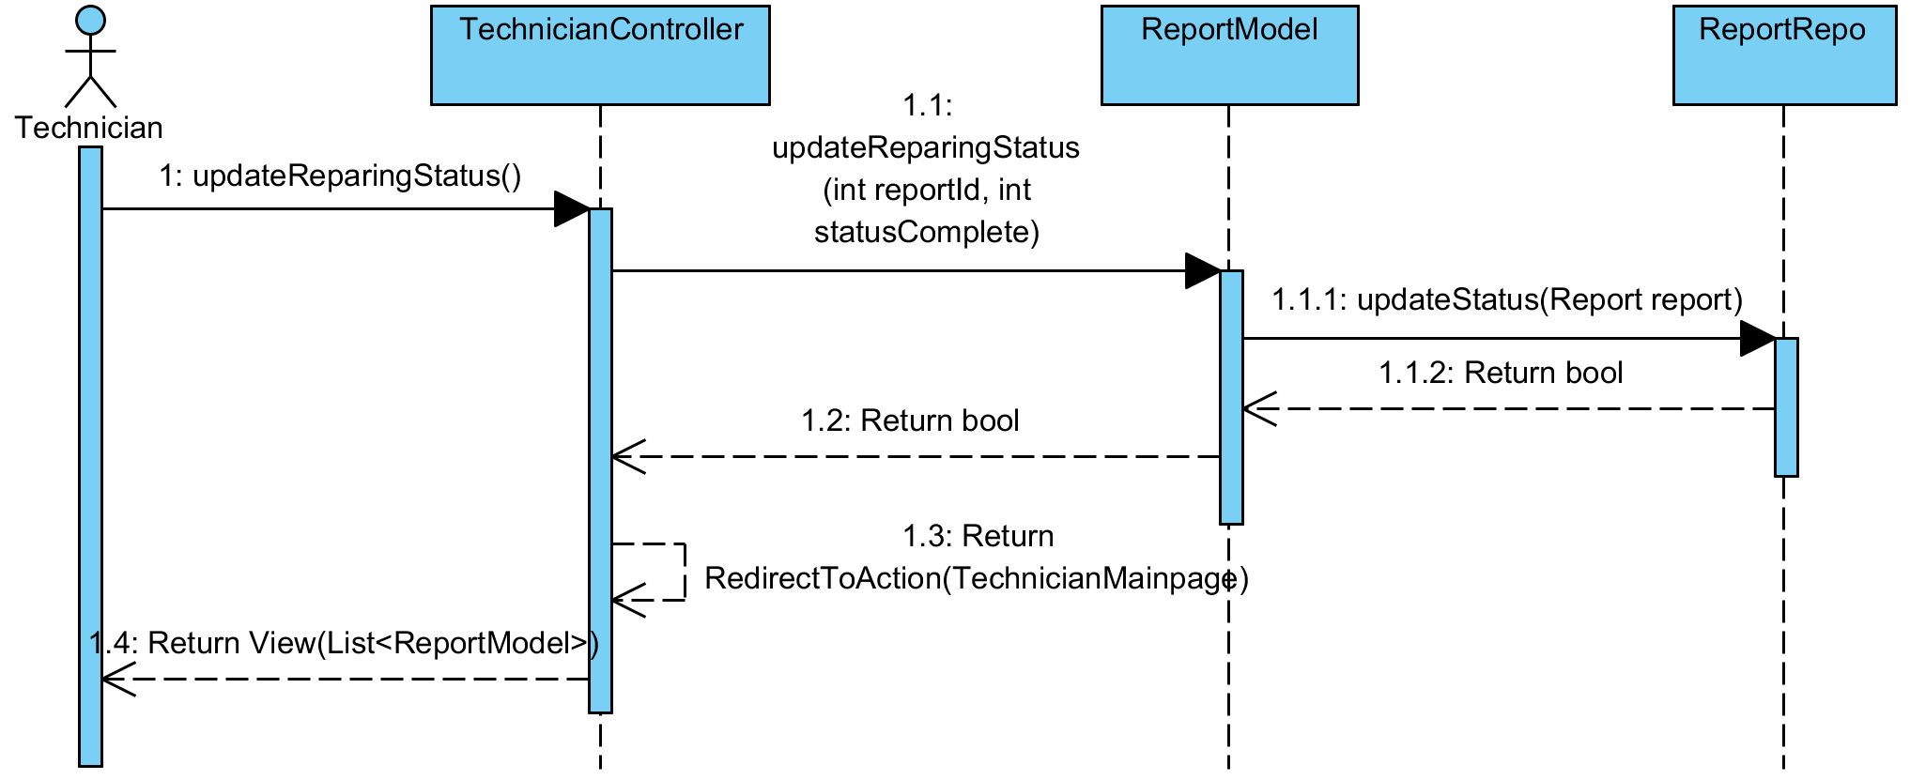

**Relate Classes Implementation**

Class-02 TechnicianController

- Method 2.12

Class-07 ReportModel

- Method 7.18

Class-16 ReportRepo

- Method 16.3

**3.2.27 Sequence Diagram (SD 19): Technician can view IT equipment information**

**: This sequence diagram responses to**

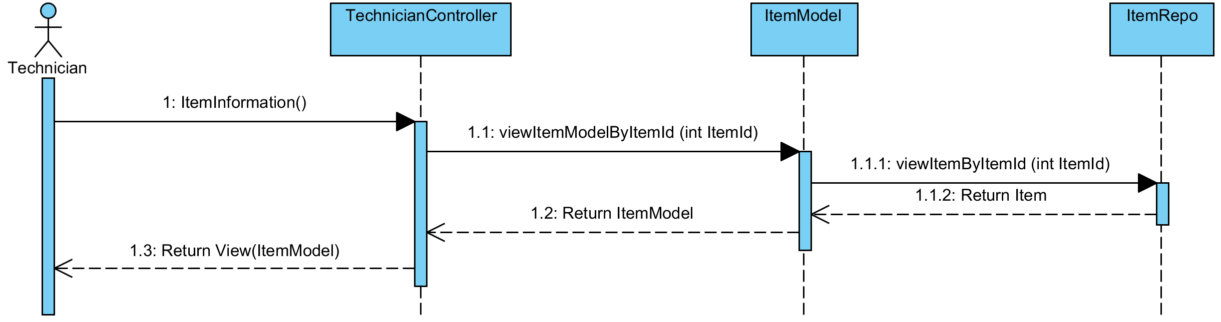

**Relate Classes Implementation**

Class-02 TechnicianController

- Method 2.3

Class-05 ItemModel

- Method 5.18

Class-14 ItemRepo

- Method 4.11

**3.2.28 Sequence Diagram (SD 20): Technician can view Reporter information**

**: This sequence diagram responses to**

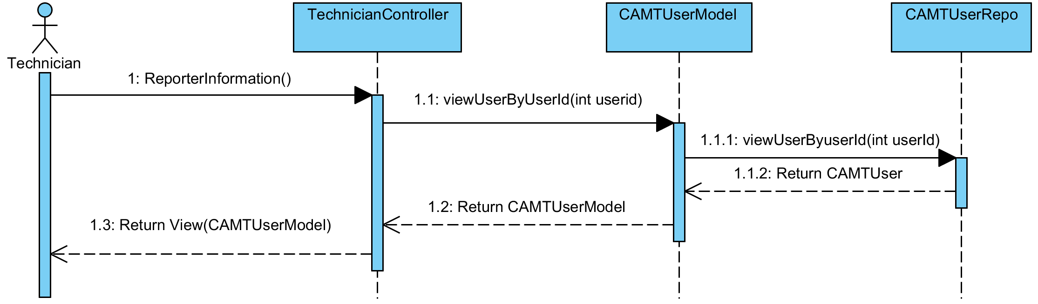

**Relate Classes Implementation**

Class-02 TechnicianController

- Method 2.8

Class-04 CAMTUserModel

- Method 4.19

Class-13 CAMTUserRepo

- Method 13.7

**3.2.29 Sequence Diagram (SD 21): Technician can view all IT equipment that live in repair process**

**: This sequence diagram responses to**

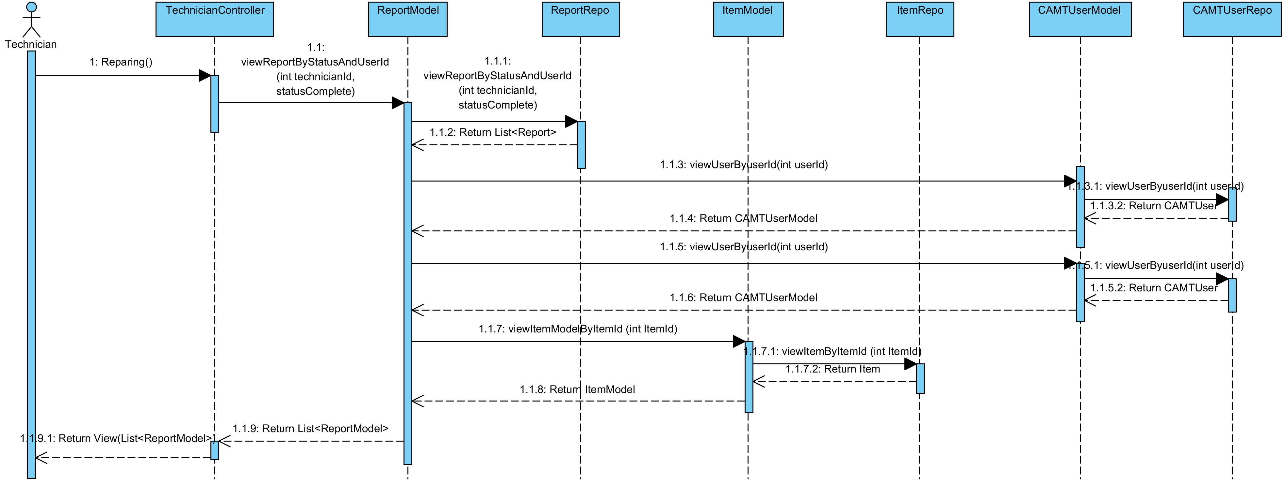

**Relate Classes Implementation**

Class-02 TechnicianController

- Method 2.4

Class-07 ReportModel

- Method 7.23

Class-16 ReportRepo

- Method 16.9

Class-05 ItemModel

- Method 5.18

Class-14 ItemRepo

- Method 14.11

Class-04 CAMTUserModel

- Method 4.19

Class-13 CAMTUserRepo

- Method 13.7

**3.2.30 Sequence Diagram (SD 22.1): Technician can update repair task information**

**: This sequence diagram responses to**

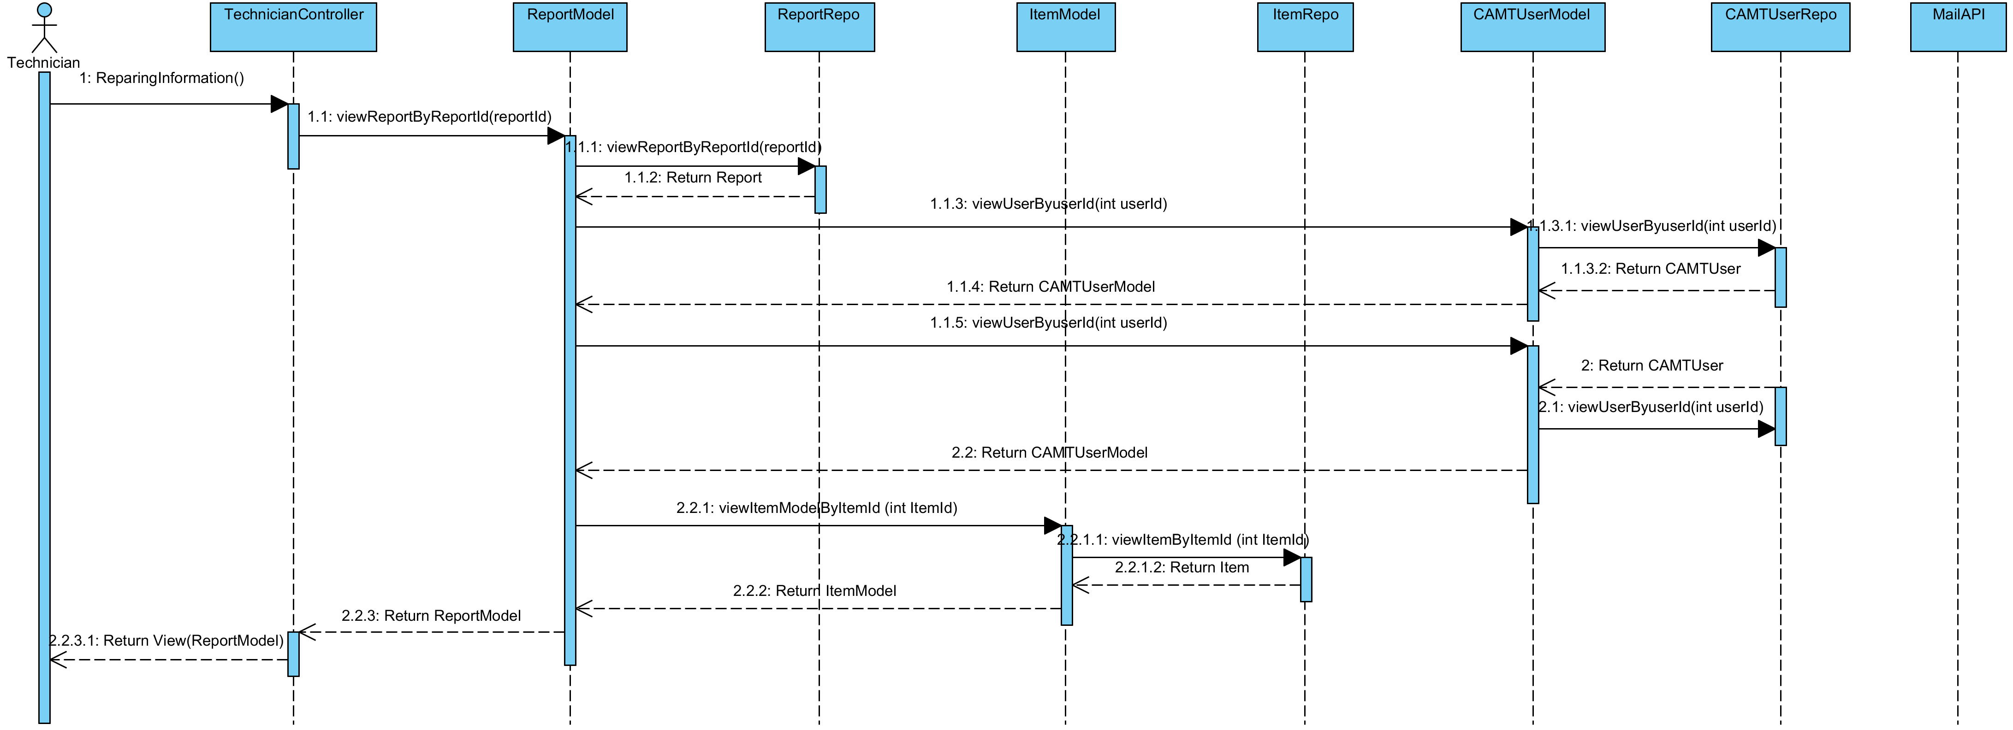

**Relate Classes Implementation**

Class-02 TechnicianController

- Method 2.7

Class-07 ReportModel

- Method 7.23

Class-16 ReportRepo

- Method 16.9

Class-05 ItemModel

- Method 5.18

Class-14 ItemRepo

- Method 14.11

Class-04 CAMTUserModel

- Method 4.19

Class-13 CAMTUserRepo

- Method 13.7

**3.2.31 Sequence Diagram (SD 22.2): Technician can update repair task information.**

**: This sequence diagram responses to**

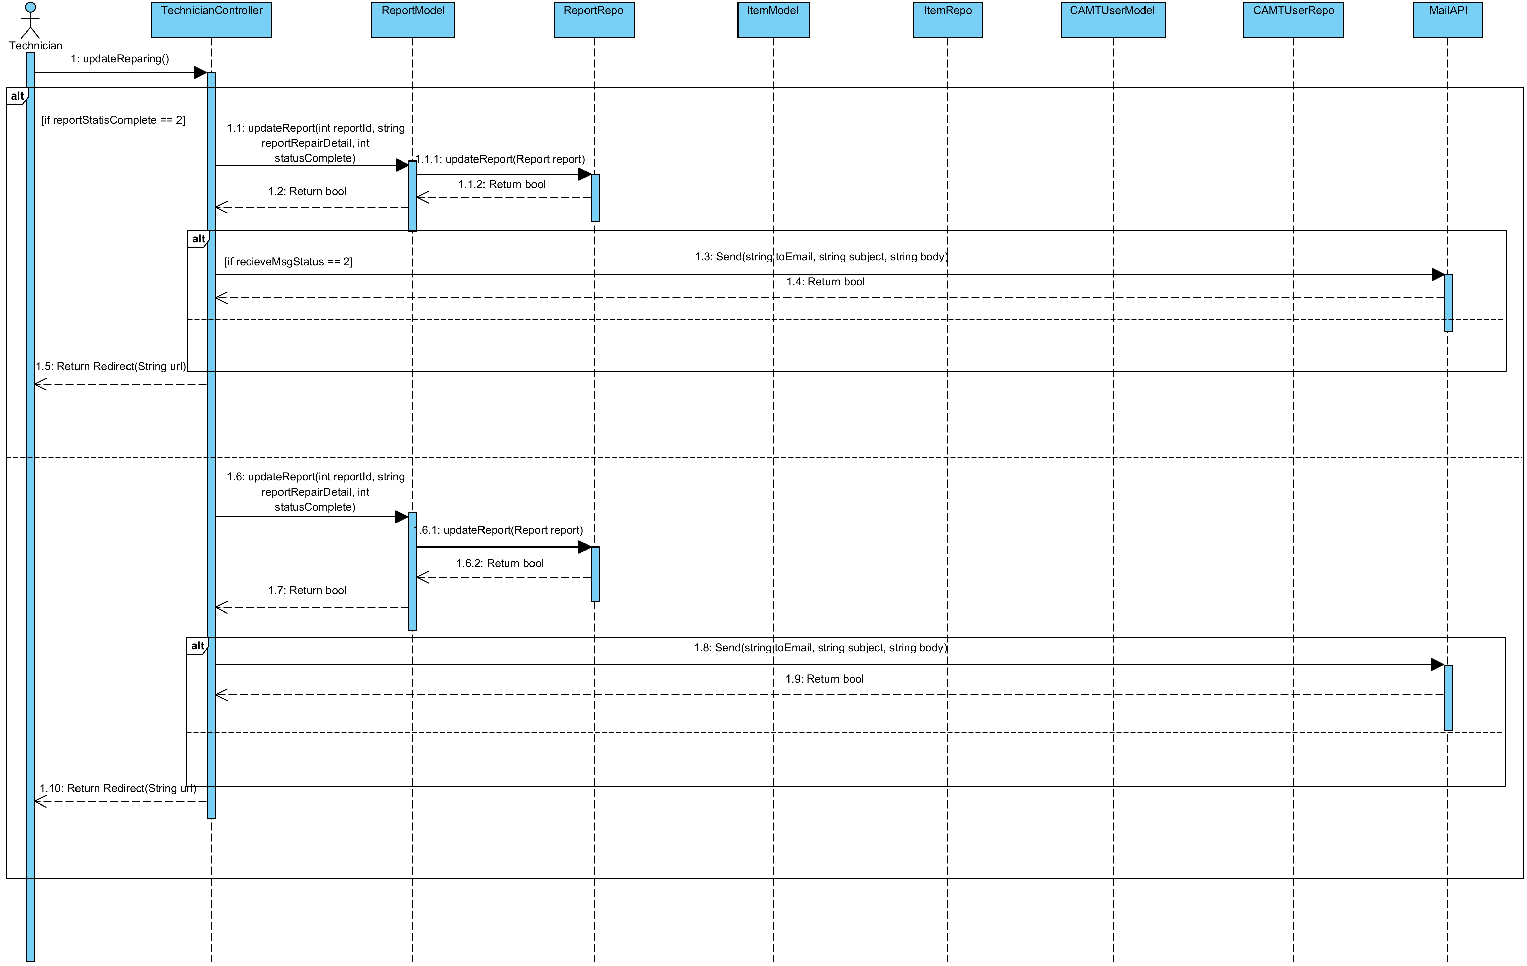

**Relate Classes Implementation**

Class-02 TechnicianController

- Method 2.11

Class-07 ReportModel

- Method 7.19

Class-16 ReportRepo

- Method 16.2

Class-05 ItemModel

Class-14 ItemRepo

Class-04 CAMTUserModel

Class-13 CAMTUserRepo

Class-08 MailAPI

- Method 8.9

**3.2.32 Sequence Diagram (SD 23.1): Technician can view history IT equipment that were repaired**

**: This sequence diagram responses to**

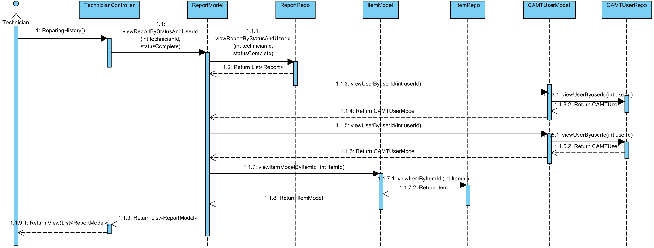

**Relate Classes Implementation**

Class-02 TechnicianController

- Method 2.5

Class-07 ReportModel

- Method 7.23

Class-16 ReportRepo

- Method 16.9

Class-05 ItemModel

- Method 5.18

Class-14 ItemRepo

- Method 14.11

Class-04 CAMTUserModel

- Method 4.19

Class-13 CAMTUserRepo

- Method 13.7

**3.2.33 Sequence Diagram (SD 23.2): Technician can view history IT equipment that were repaired**

**: This sequence diagram responses to**

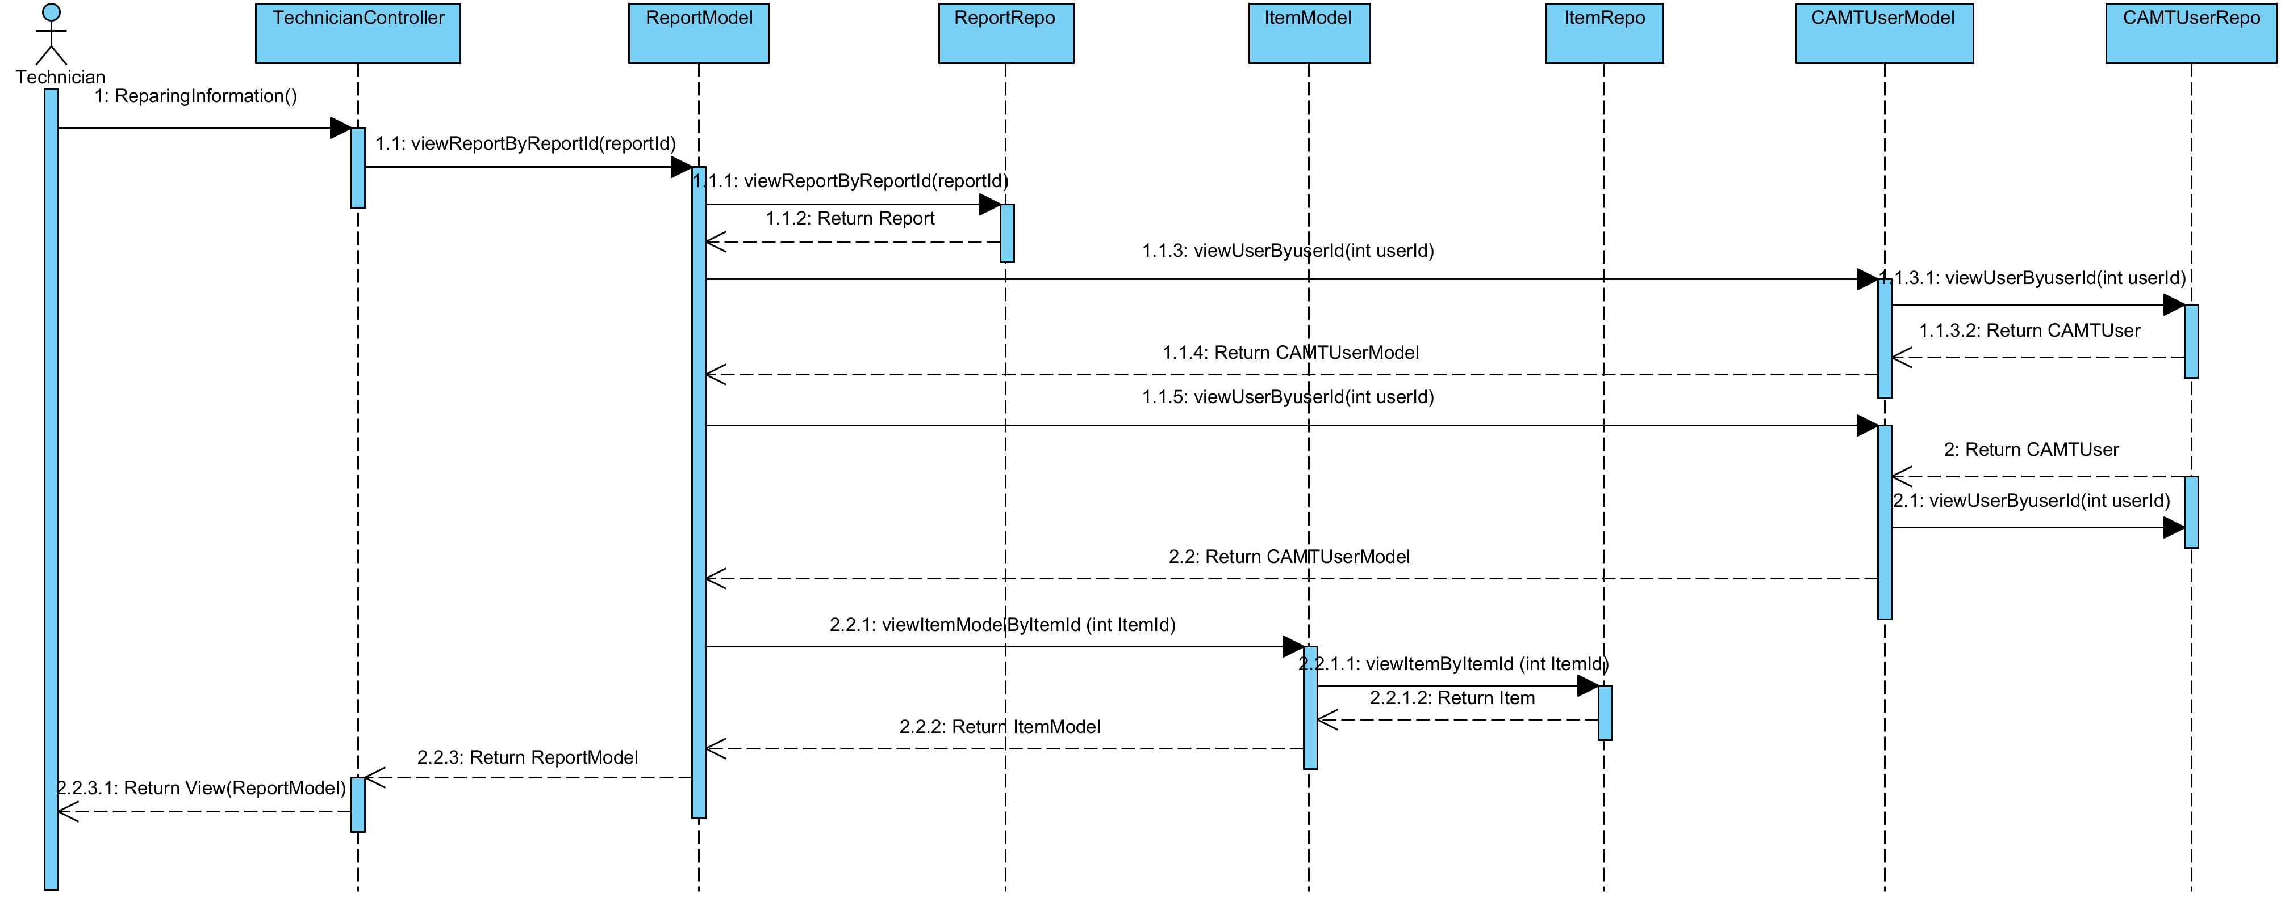

**Relate Classes Implementation**

Class-02 TechnicianController

- Method 2.7

Class-07 ReportModel

- Method 7.22

Class-16 ReportRepo

- Method 16.8

Class-05 ItemModel

- Method 5.18

Class-14 ItemRepo

- Method 14.11

Class-04 CAMTUserModel

- Method 4.19

Class-13 CAMTUserRepo

- Method 13.7

**3.2.33 Sequence Diagram (SD 24-1): Technician can update his account information (update basic information)**

**: This sequence diagram responses to**

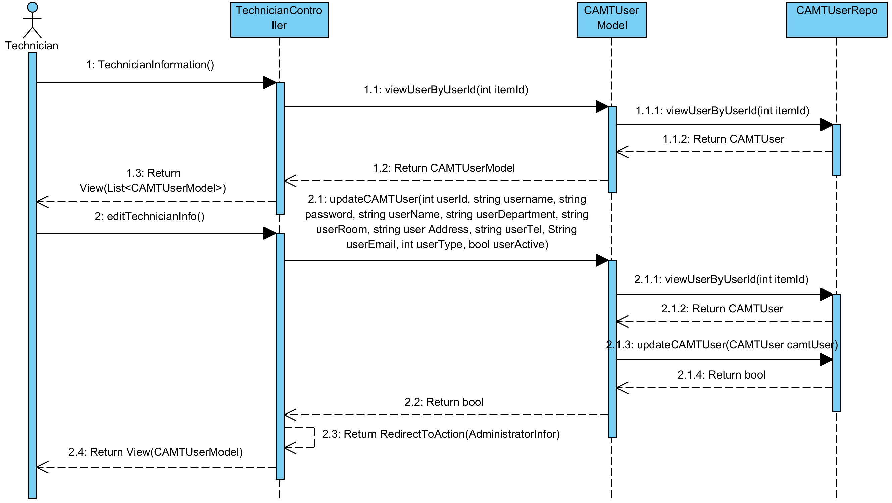

**Relate Classes Implementation**

Class-02 TechnicianController

- Method 2.9, 2.1

Class-04 CAMTUserModel

- Method 4.19, 4.15

Class-13 CAMTUserRepo

- Method 13.7, 13.3

**3.2.35 Sequence Diagram (SD 24-2): Technician can update his account information (update password)**

**: This sequence diagram responses to**

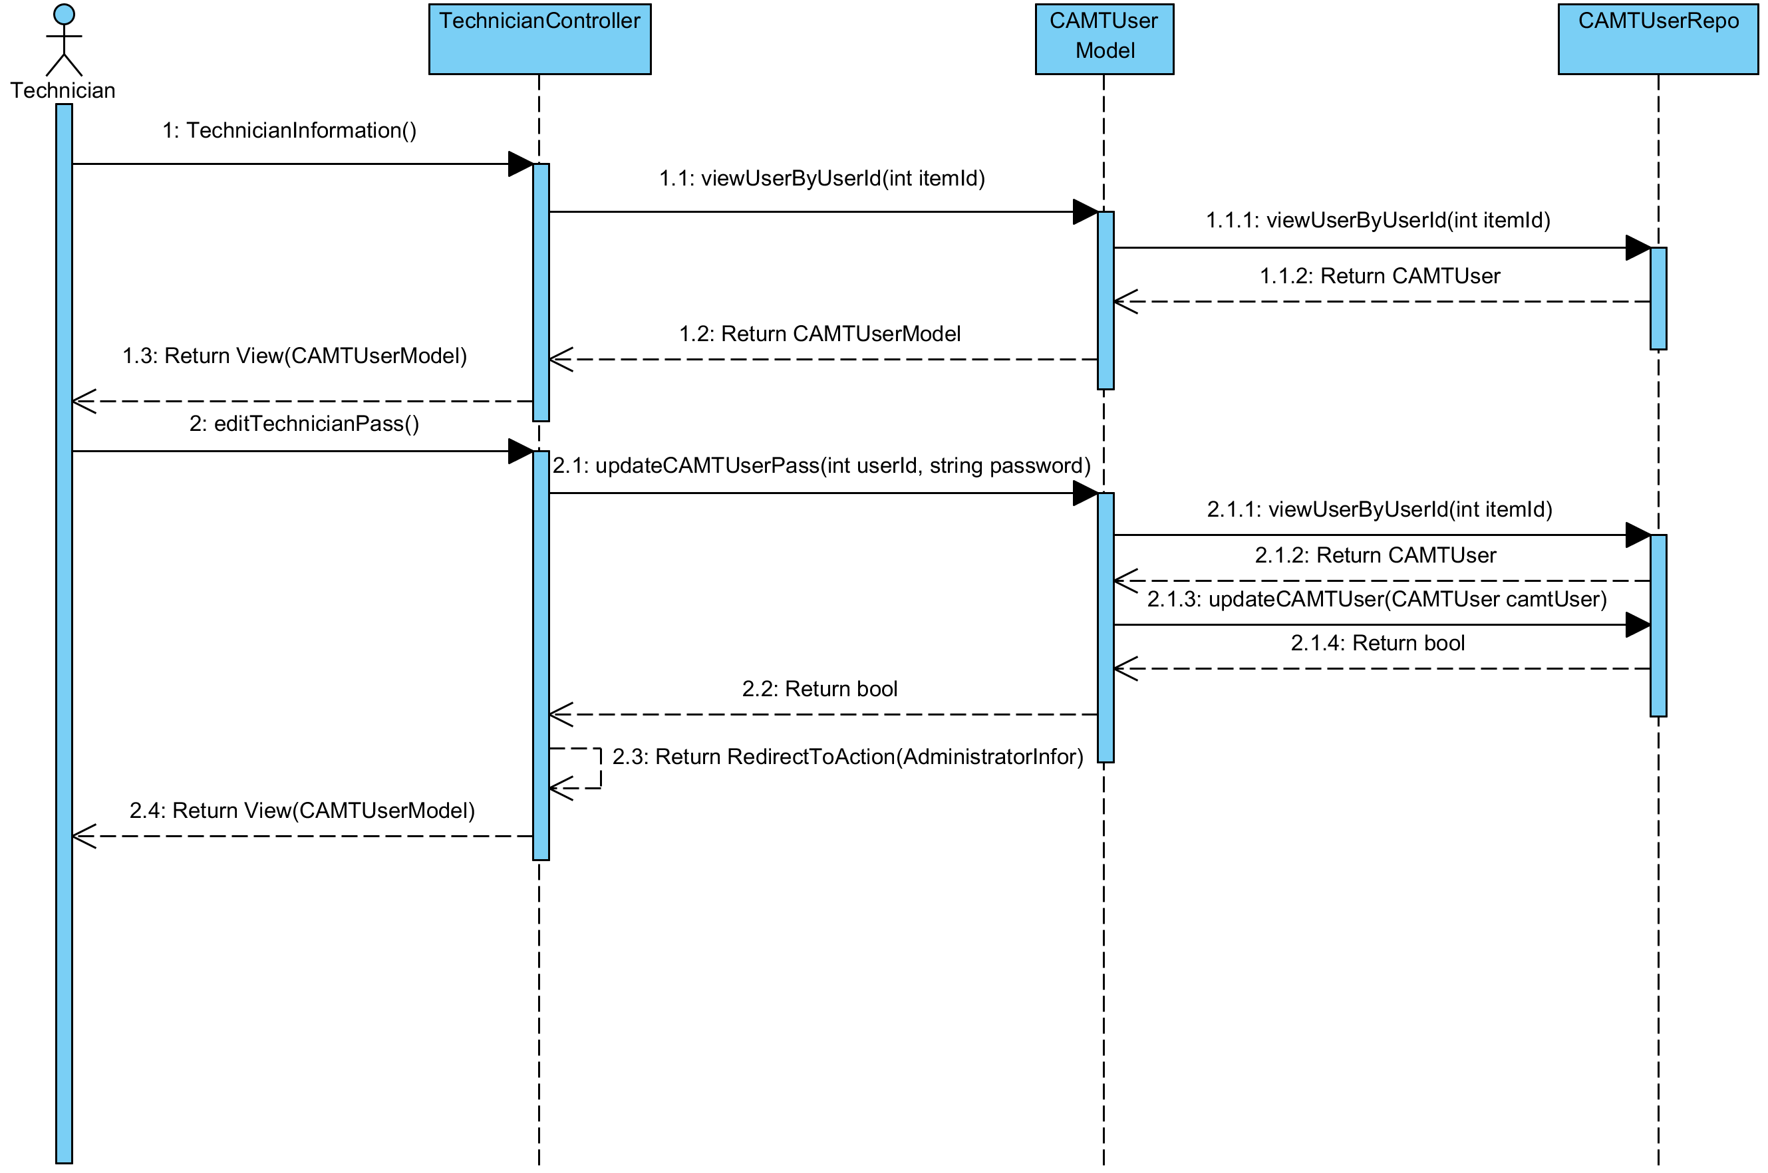

**Relate Classes Implementation**

Class-02 TechnicianController

- Method 2.9, 2.2

Class-04 CAMTUserModel

- Method 4.19, 4.16

Class-14 CAMTUserRepo

- Method 14.7, 14.3

**3.2.36 Sequence Diagram (SD 25): Reporter can inform a broken IT equipment**

**: This sequence diagram responses to**

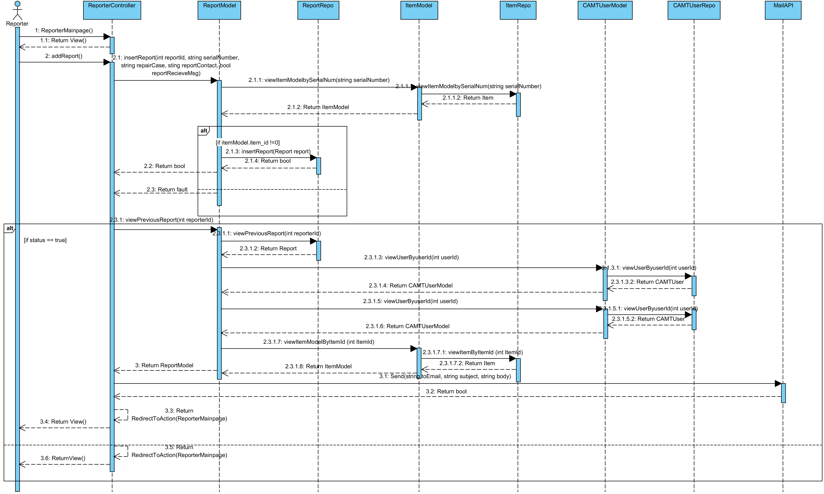

**Relate Classes Implementation**

Class-03 ReporterController

- Method 3.6, 3.1

Class-07 ReportModel

- Method 7.14, 7.20

Class-16 ReportRepo

- Method 16.1, 16.6

Class-05 ItemModel

- Method 5.19, 5.18

Class-14 ItemRepo

- Method 14.7, 14.11

Class-04 CAMTUserModel

- Method 4.19

Class-13 CAMTUserRepo

- Method 13.7

Class-08 MailAPI

- Method 8.9

**3.2.37 Sequence Diagram (SD 26): Reporter can view all IT equipment that he inform**

**: This sequence diagram responses to**

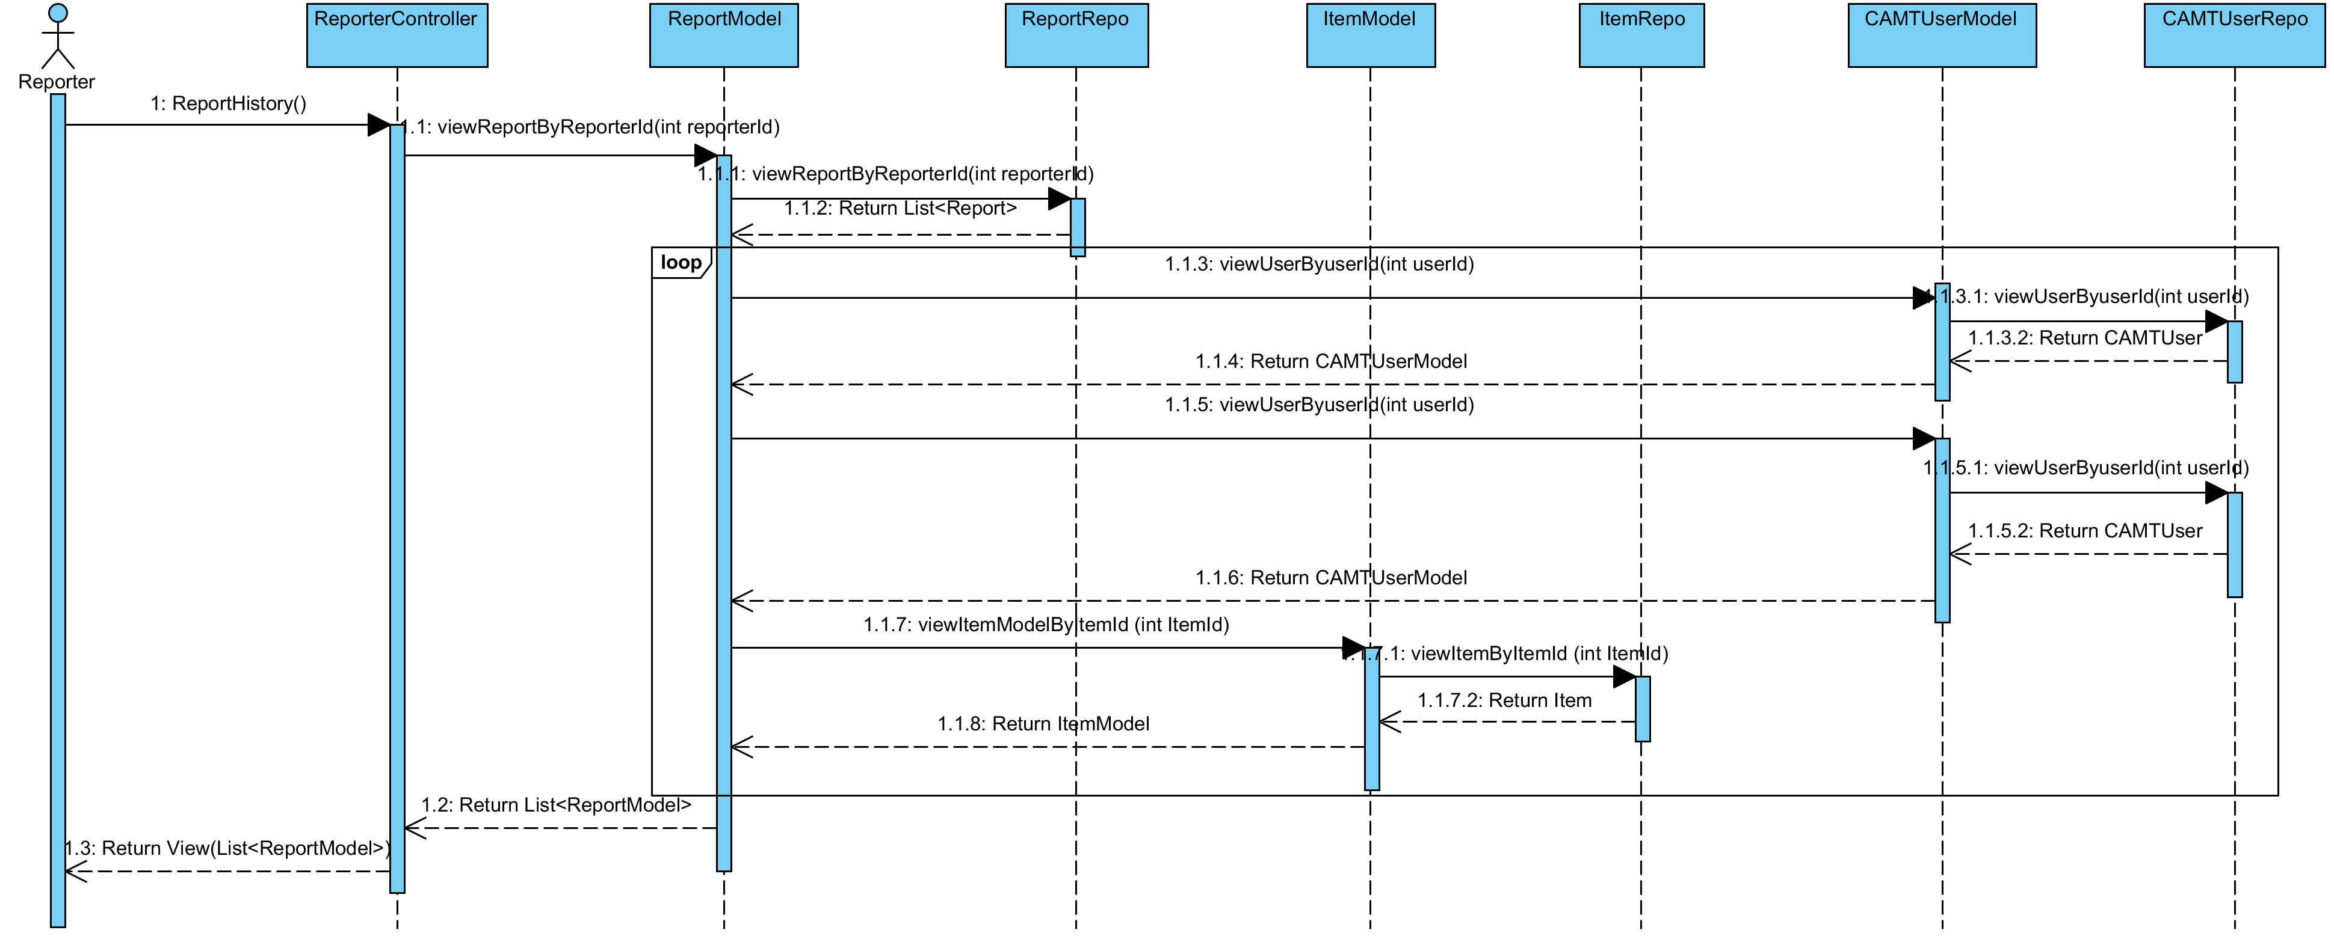

**Relate Classes Implementation**

Class-03 ReporterController

- Method 3.7

Class-07 ReportModel

- Method 7.21

Class-16 ReportRepo

- Method 16.7

Class-05 ItemModel

- Method 5.18

Class-14 ItemRepo

- Method 14.11

Class-04 CAMTUserModel

- Method 4.19

Class-13 CAMTUserRepo

- Method 13.7

**3.2.38 Sequence Diagram (SD 27): Reporter can view IT equipment Information**

**: This sequence diagram responses to**

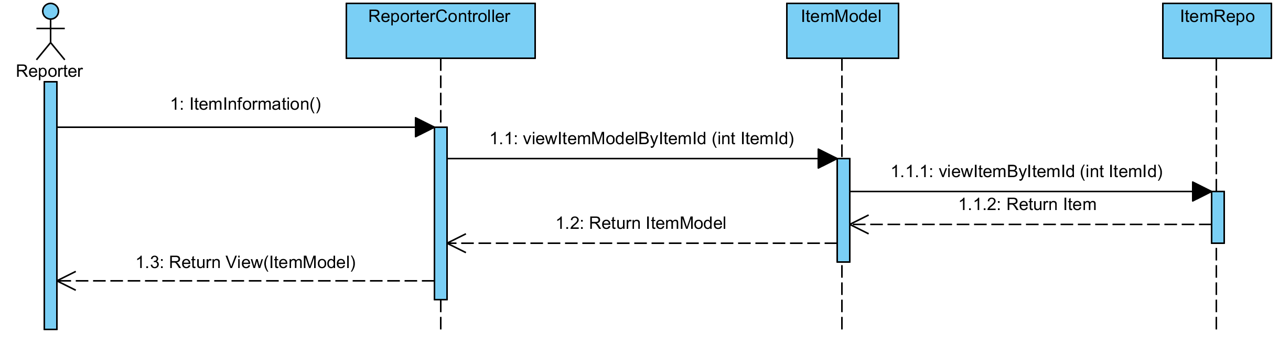

**Relate Classes Implementation**

Class-03 ReporterController

- Method 3.4

Class-05 ItemModel

- Method 5.18

Class-14 ItemRepo

- Method 14.11

**3.2.39 Sequence Diagram (SD 28-1): Reporter can update his account information (update basic information)**

**: This sequence diagram responses to**

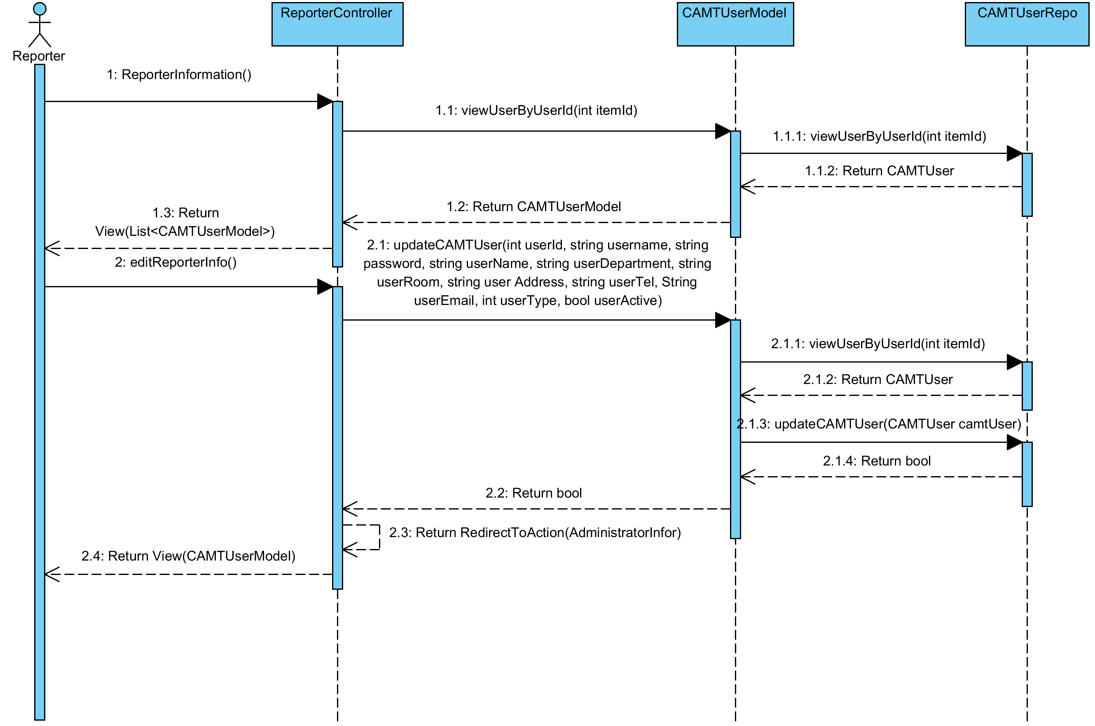

**Relate Classes Implementation**

Class-03 ReporterController

- Method 3.5, 3.2

Class-04 CAMTUserModel

- Method 4.19, 4.15

Class-13 CAMTUserRepo

- Method 13.7, 13.3

**3.2.40 Sequence Diagram (SD 28-2): Reporter can update his account information (update password)**

**: This sequence diagram responses to**

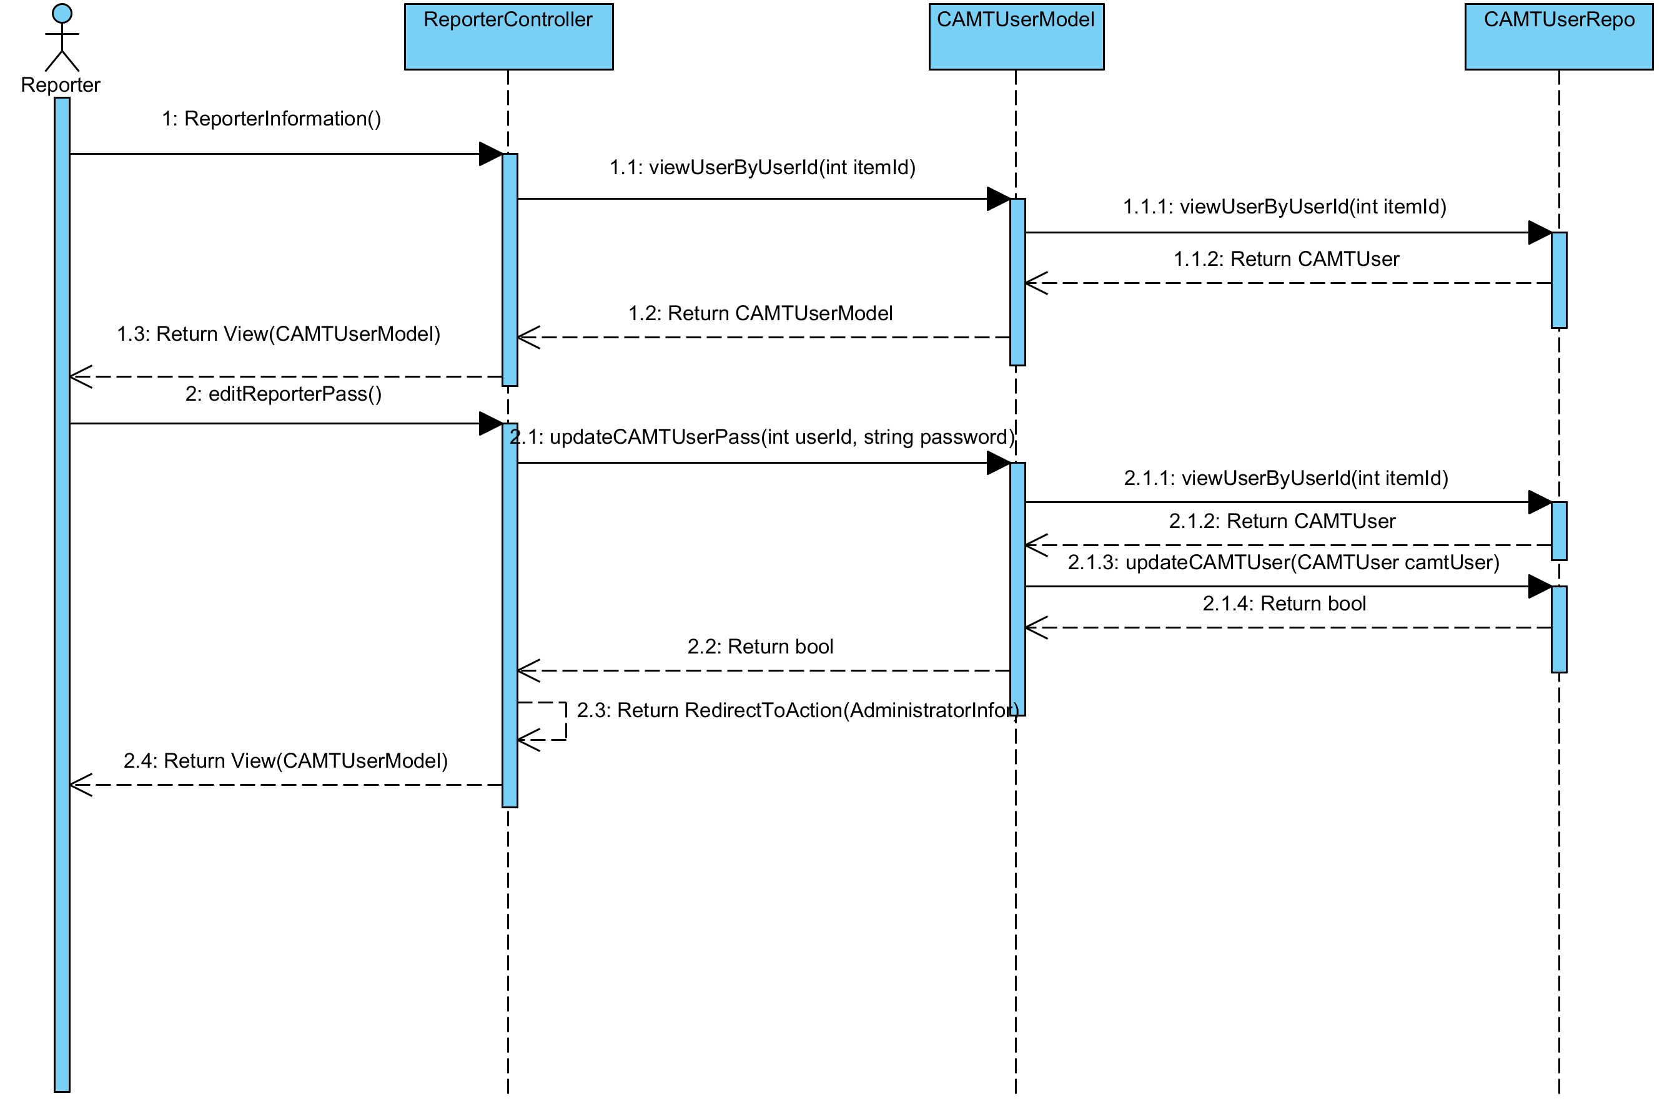

**Relate Classes Implementation**

Class-03 ReporterController

- Method 3.5, 3.3

Class-04 CAMTUserModel

- Method 4.19, 4.16

Class-13 CAMTUserRepo

- Method 13.7, 13.3

**3.2.41 Sequence Diagram (SD 29): User can logout**

**: This sequence diagram responses to**

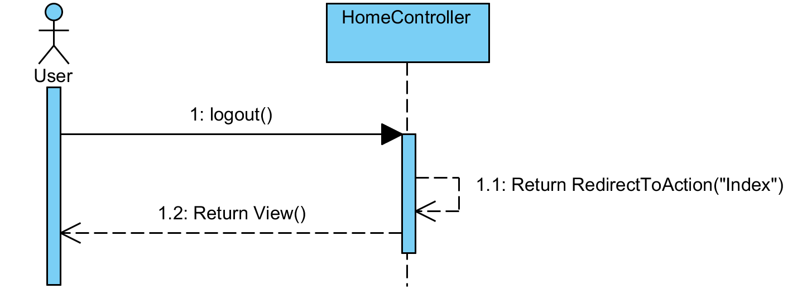

**Relate Classes Implementation**

Class-01 HomeController

- Method 1.22

## **3.3 Database design**

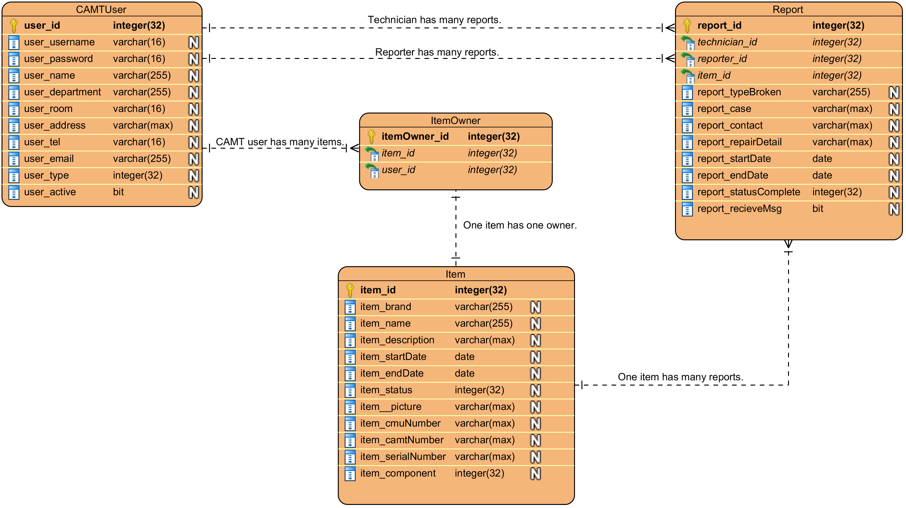

**3.1.1 Table CAMTUser**

**Description:** CAMTUser table stores all the user account information.

|  |  |  |  |  |  |  |
| --- | --- | --- | --- | --- | --- | --- |
| **Field Name** | **Description** | **Type** | **Length** | **Primary Key** | **Foreign Key** | **Nullable** |
| user_id | The user’s identifier | integer | 32 | PK | - | Not Null |
| user_username | The user’s username | varchar | 16 | - | - | Not Null |
| user_password | The user’s password | varchar | 16 | - | - | Not Null |
| user_name | The user’s name | varchar | 255 | - | - | Not Null |
| user_department | The user’s department | varchar | 255 | - | - | Not Null |
| user_room | The user’s room | varchar | 16 | - | - | Null |
| user_address | The user’s address | varchar | Max | - | - | Not Null |
| user_tel | The user’s telephone NO. | varchar | 16 | - | - | Not Null |
| user_email | The user’s email | varchar | 255 | - | - | Not Null |
| user_type | The type of the user account  1 The administrator  2 The technician 3 The reporter | integer | 32 | - | - | Not Null |
| user_active | The active status of the user 0 Inactive 1 Active | bit | 1 | - | - | Not Null |

**3.1.2 Table Item**

**Description:** Item table stores all the IT equipment information.

|  |  |  |  |  |  |  |
| --- | --- | --- | --- | --- | --- | --- |
| **Field Name** | **Description** | **Type** | **Length** | **Primary Key** | **Foreign Key** | **Nullable** |
| item_id | The IT equipment identifier | integer | 32 | PK | - | Not Null |
| item_brand | The IT equipment brand | varchar | 255 | - | - | Null |
| item_name | The IT equipment name | varchar | 255 | - | - | Null |
| item_description | The IT equipment description | varchar | max | - | - | Null |
| item_startDate | The start date of using IT equipment | datetime2 | 7 | - | - | Not Null |
| item_endDate | The end date of using IT equipment | datetime2 | 7 | - | - | Null |
| item_status | The IT equipment status | integer | 32 | - | - | Not Null |
| item_picture | The IT equipment picture | varchar | max | - | - | Null |
| item_cmuNumber | The CMU number of IT equipment | varchar | max | - | - | Null |
| item_camtNumber | The CAMT number of IT equipment | varchar | max | - | - | Null |
| item_serialNumber | The serial number of IT equipment | varchar | max | - | - | Null |
| Item_component | The component of IT equipment | integer | 32 | - | - | Null |

**3.1.3 Table Report**

**Description:** Report table stores all report of the repair.

|  |  |  |  |  |  |  |
| --- | --- | --- | --- | --- | --- | --- |
| **Field Name** | **Description** | **Type** | **Length** | **Primary Key** | **Foreign Key** | **Nullable** |
| report_id | The report identifier | integer | 32 | PK | - | Not Null |
| technician_id | The technician identifier | integer | 32 | - | FK | Not Null |
| reporter_id | The reporter identifier | integer | 32 | - | FK | Not Null |
| item_id | The IT equipment identifier | integer | 32 | - | FK | Not Null |
| report__typeBroken | The report of the broken IT equipment type | varchar | 255 | - | - | Not Null |
| report_case | The report of the repair case | varchar | max | - | - | Not Null |
| report_contact | The report of the contact information | varchar | max | - | - | Not Null |
| report_repairDetail | The report of the repair detail | varchar | max | - | - | Not Null |
| report_startDate | The start date of the report | datetime2 | 7 | - | - | Not Null |
| report_endDate | The end date of the report | datetime2 | 7 | - | - | Null |
| report_statusComplete | The status of repair process 1 Waiting for defining the broken type  2 Waiting for repair  3 In the repair process 4 Completed repair | integer | 32 | - | - | Not Null |
| report_recieveMsg | The component of IT equipment 0 Not require the notification 1 Require the notification | bit | 1 | - | - | Not Null |

**3.1.4 Table itemOwner**

**Description:** itemOwner table stores

|  |  |  |  |  |  |  |
| --- | --- | --- | --- | --- | --- | --- |
| **Field Name** | **Description** | **Type** | **Length** | **Primary Key** | **Foreign Key** | **Nullable** |
| itemOwner_id | The IT equipment owner’s identifier | integer | 32 | PK | - | Not Null |
| item_id | The IT equipment identifier | integer | 32 | - | FK | Not Null |
| user_id | The user identifier | integer | 32 | - | FK | Not Null |